2022 SAFETY PLAN INFORMATION

Petaluma American Little League’s
commitment to safety;

Our league will annually publish a current Safety Plan. This plan is distributed to every manager, coach and parent volunteer before any practices or games take place.

Our Safety Officer is: Brandon Deering

can be reached at 707-333-4577

or through email at: Brandon.deering707@gmail.com

Table of Contents

Page
3 Mission Statement
4 Safety Program Mission
6 First Aid
12 Emergency Phone Numbers
13 Hands only CPR
14 Choking
15 Communicable Disease Program
16 COVID-19 Guidelines
17 Board of Directors
18 Concussions
21 Fire Extinguishers
22 Drug Awareness
23 League Safety Code
26 Safety Responsibilities
30 Pre-Season Training Dates
31 Batting Cage Guidelines
33 Umpires
36 Conditioning and Stretching
38 Pitch Count
39 Hydration
40 Common Sense
41 Equipment
43 Weather
45 Evacuation Plan
47 Machinery
48 General Facility
49 Snack Bar Safety
50 Accident Reporting Procedure
52 Insurance Policies
54 Filing a Claim
55 SafeSport Act - Child Protection Program
58 Finger-Print Based Background Checks
60 Immunity from Liability
61 Transportation
62 Forms

OUR MISSION STATEMENT

Little League is a Non-profit Organization run by Volunteers of our community who are committed to the children and their families in our community to implant firmly the ideals of good sportsmanship, honesty, loyalty, courage and respect for one another and authority, so that they may be well adjusted, stronger and happier children and will grow to become good, decent, healthy, and trustworthy citizens. We will provide an opportunity for our community’s children to learn the game of Baseball in a safe and friendly environment.

SAFETY PROGRAM MISSION

The mission of our league’s safety program is to maintain a high degree of safety awareness to ensure our league is safe for the players. In addition, this document communicates what is expected from all Coaches, Players, Volunteers and Parents. It is the policy of our league to provide an environment in which the risk of injury is reduced to the lowest possible level by the application of our published safety code. Behavior in violation of the safety code will be treated as misconduct and may remit in the application of appropriate corrective action up to and including dismissal.

Little League Policy and CA District 35

One of the reasons for Little Leagues’ wide acceptance and phenomenal growth is that it fills an important need in our free society. As our program expands, it takes, more and more, a major part in the development of young people. It instills confidence and an understanding of fair play and the rights of other people.

Many of our younger children may develop slower than others are given an opportunity not only to develop their playing skill but to learn what competition and sportsmanship are all about. All who take part in our program is encouraged to develop a high moral code along with their improvement in physical skills and coordination. These high aims are more for the benefit of the great majority of children rather than the few who would otherwise come to the top in any competitive athletic endeavor.

You can never eliminate all of the possible injuries, however having a plan and using preventive safety precautions increase the odds for injury-free involvement in baseball.

Four “E’s” of Safety

EDUCATION refers to the important matter of including suitable safety precautions in instructions, training, communications, drill work and follow-up.

EQUIPMENT applies to the safe upkeep and use of physical property, fields, personal protective equipment, bleachers, bats, balls, etc.

ENTHUSIASM is the key to selling this important ingredient called safety, which can prevent painful and disabling accidents.

ENFORCEMENT should be applied more as an incentive for skillful ball playing rather than as disciplinary action. Far better results can be obtained by praise and recognition than by forcing players into line. Tactful guidance must be backed by firmness and justly used discipline.

DEFINING AND UNDERSTANDING TERMS IN THIS DOCUMENT
ACCIDENT is a sudden, undesirable and unplanned occurrence often resulting in bodily injury, disability and/or property damage.
ACCIDENT CAUSE is an unsafe condition, situation or act that may result directly in or contribute to the occurrence of an accident.
CORRECTIVE ACTION is the positive steps or measures taken to eliminate, or at least minimize, an accident cause.
HAZARD refers to a condition or a situation that could cause an accident.
INJURY is the physical harm or damage often resulting from an accident.
INSURANCE CLAIM refers to the right of a parent, as in the case of accident insurance to have eligible medical expenses resulting from an accidental injury connected with a game or scheduled practice paid by the appropriate insurance company
TYPE OF ACCIDENT is a phrase used to describe an unintentional, sudden incident that can be identified so effective counter measures may be taken. Examples are: struck by, tripped, fell, collision with, caught between, etc.
AN UNSAFE ACT refers to unintentional human failure or lack of skill that can lead to an accident. It is one of the two general accident causes, the other being an unsafe condition.
AN UNSAFE CONDITION is an abnormal or faulty situation or condition which may cause an accident. Its presence, particularly when an unsafe act is committed, may result in an accident.
It is a recognized that the area personnel and facilities available for the operation of a Little League will dictate the structure of an effective safety program. These safety guidelines are presented as a goal toward which the
adults who administer a league can work. The effectiveness of their efforts to prevent accidents will be measured more by their sincerity of purpose than by the amount of money and preponderance of volunteer effort at their disposal.

FIRST AID

First aid is an important part of any safety program. Like insurance coverage, it is a form of protection that must be available in case of an emergency involving any injury.

Definition
First aid is the immediate, necessary, temporary, emergency care given for injuries. First-Aid means exactly what the term implies -- it is the first care given to a victim. It is usually performed by the first person on the scene and continued until professional medical help arrives.

At no time should anyone administering First-Aid go beyond his or her capabilities

Selection and Qualifications of First Aiders
At least one coach per team will receive first aid training prior to the start of the season. It is impractical to have a completely trained and experienced first aid person on duty at all times. However, our league will make every effort should be made to have several alternate first aid trained persons available. These persons will be trained in the basic requirements of first aid treatment, and their duties will keep them at the league’s fields.

Ideally, this training should be from an accredited agency such as the American Red Cross. The alternative is to have first aid trained individual briefly and specifically for this purpose by a medical doctor or a registered nurse who is familiar with Little League operations. Minimum first aid training should include the handling of extreme emergencies such as the usage of mouth-to-mouth resuscitation and external cardiac massage.

Know your limits!
The average response time on 9-1-1 calls is 5-7 minutes. En-route Paramedics are in constant communication with the local hospital at all times preparing them for whatever emergency action might need to be taken. You cannot do this. Therefore, do not attempt to transport a victim to a hospital. Perform whatever First Aid you can and wait for the paramedics to arrive.

First Aid-Kits
First Aid Kits will be furnished to each team at the beginning of the season. The League’s Safety Officer’s name and phone number are taped on the inside lid of all First-Aid Kits. Keep the necessary change inside the First-Aid Kit for emergency telephone calls. The First Aid Kit will become part of the Team’s equipment package and shall be taken to all practices, batting cage practices, games (whether season or post-season) and any other Little League event where children’s safety is at risk.

Inventory your kit weekly. To replenish materials in the Team First Aid Kit, the Manager, designated coaches or the appointed Team Safety Officer must contact the League’s Safety Officer.

First Aid Kits and this Safety Manual must be turned in at the end of the season along with your equipment package.

The First Aid Kit following items:
5 Instant Ice Packs 2 Plastic Bags for Ice
6 Antiseptic Wipes 2 Large Bandages 2”x4”
2 Large Non-stick Bandages 20 Band-Aids 1”x3”
2 Sterile Gauze Pads 1 Cloth Athletic Tape
2 Eye Pads1 Roll of Gauze 1 Scissors
1 Pair of Latex Gloves 1 Tweezers

Good Samaritan Laws
There are laws to protect you when you help someone in an emergency situation. The “Good Samaritan Laws” give legal protection to people who provide emergency care to ill or injured persons. When citizens respond to an emergency and act as a reasonable and prudent person would under the same conditions, Good Samaritan immunity generally prevails. This legal immunity protects you, as a rescuer, from being sued and found financially responsible for the victim’s injury. For example, a reasonable and prudent person would –
- Move a victim only if the victim’s life was endangered.
- Ask a conscious victim for permission before giving care.
- Check the victim for life-threatening emergencies before providing further care.
- Summon professional help to the scene by calling 9-1-1.
- Continue to provide care until more highly trained personnel arrive.

Good Samaritan laws were developed to encourage people to help others in emergency situations. They require that the “Good Samaritan” use common sense and a reasonable level of skill, not to exceed the scope of the individual’s training in emergency situations. They assume each person would do his or her best to save a life or prevent further injury. People are rarely sued for helping in an emergency. However, the existence of Good Samaritan laws does not mean that someone cannot sue. In rare cases, courts have ruled that these laws do not apply in cases when an individual rescuer’s response was grossly or willfully negligent or reckless or when the rescuer abandoned the victim after initiating care.

Every manager needs a gallon size Ziploc bag. With 2 sets of gloves and paper towels. Only to be used if there is blood or open wounds. Once the first aid has been given please put gloves and paper towels in the Ziploc bag and dispose. This will protect everyone.

Permission to Give Care

If the victim is conscious, you must have his/her permission before giving first-aid. To get permission you must tell the victim who you are, how much training you have, and how you plan to help. Only then can a conscious victim give you permission to give care. Do not give care to a conscious victim who refuses your offer to give care. If the conscious victim is an infant or child, permission to give care should be obtained from a supervising adult when one is available. If the condition is serious, permission is implied if a supervising adult is not present.

Permission is also implied if a victim is unconscious or unable to respond. This means that you can assume that, if the person could respond, he or she would agree to care.
Treatment At Site -
Do . . .
- Access the injury. If the victim is conscious, find out what happened, where it hurts, watch for shock.
- Know your limitations.
- Call 9-1-1 immediately if person is unconscious or seriously injured.
- Look for signs of injury (blood, black-and-blue, deformity of joint etc.)
- Listen to the injured player describe what happened and what hurts if conscious. Before questioning, you may have to calm and soothe an excited child.
- Feel gently and carefully the injured area for signs of swelling or grating of broken bone.
- Talk to your team afterwards about the situation if it involves them. Often players are upset and worried when another player is injured. They need to feel safe and understand why the injury occurred.
Don’t . . .
- Administer any medications.
- Provide any food or beverages (other than water).
- Hesitate in giving aid when needed.
- Be afraid to ask for help if you’re not sure of the proper Procedure, (i.e., CPR, etc.)
- Transport injured individual except in extreme emergencies.

Emergency Medical Releases:

Insurance riders are needed if any practices, games or events involving baseball, on or off our complex take place, before or after the regularly scheduled season, and “All Star” post season. Insurance riders are also necessary if non-Little League teams practice, play games, or hold tournaments at the League’s facility.

SAFETY FIRST!
BE ALERT!
CHECK PLAYING FIELD FOR HAZARDS
PLAYERS MUST WEAR PROPER EQUIPMENT
ENSURE EQUIPMENT IS IN GOOD SHAPE
MAINTAIN CONTROL OF THE SITUATION
MAINTAIN DISCIPLINE
BE ORGANIZED
KNOW PLAYERS’ LIMITS
AND DON’T EXCEED THEM
MAKE IT FUN!

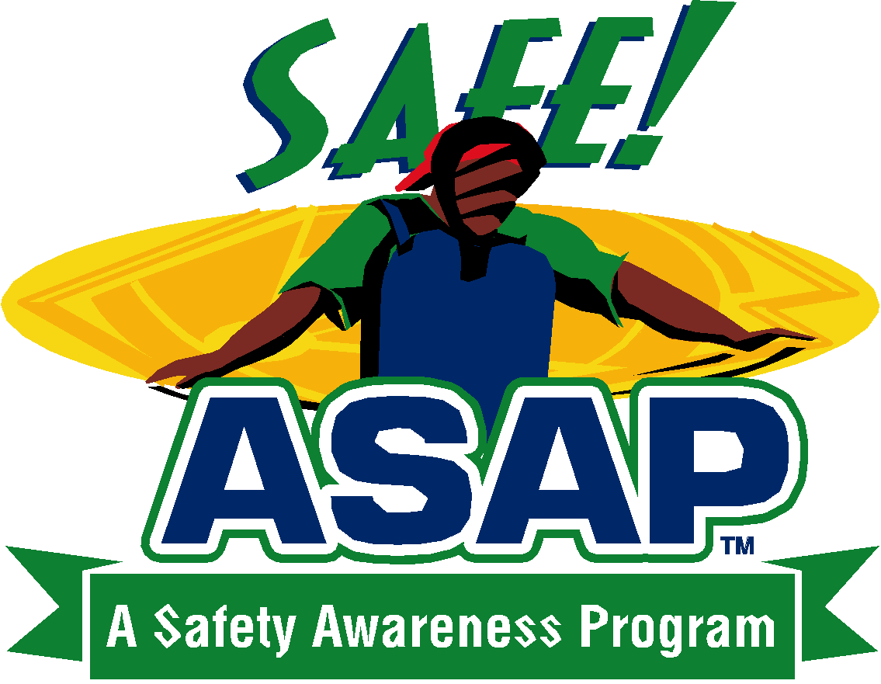

CONDITIONING & STRETCHING
CONDITI CONDITIONING & STRETCHING

WARNING: Protective equipment cannot prevent all injuries a player might receive while participating in Baseball / Softball.

9-1-1 EMERGENCY NUMBER

The most important help that you can provide to a victim who is seriously injured is to call for professional medical help. Make the call quickly, preferably from a cell phone near the injured person. If this is not possible, send someone else to make the call from a nearby telephone. Be sure that you or another caller follows these steps.
- First Dial 9-1-1.
- Give the dispatcher the necessary information. Answer any questions that he or she might ask. Most dispatchers will ask:
- The exact location or address of the emergency. Include the name of the city or town, nearby intersections, landmarks, etc.
- The telephone number from which the call is being made.
- The caller’s name.
- What happened - for example, a baseball related injury, bicycle accident, fire, fall, etc.
- How many people are involved.
- The condition of the injured person - for example, unconsciousness, chest pains, or severe bleeding.
- What help (first aid) is being given.
- Do not hang up until the dispatcher hangs up. The EMS dispatcher may be able to tell you how to best care for the victim.
- Continue to care for the victim till professional help arrives.
- Appoint somebody to go to the street and look for the ambulance and fire engine and flag them down if necessary. This saves valuable time. Remember, every minute counts.

When to call - If you have any doubt at all, call 9-1-1 and requests paramedics.
If the injured person is unconscious, call 9-1-1 immediately. Sometimes a conscious victim will tell you not to call an ambulance, and you may not be sure what to do. Call 9-1-1 anyway and request paramedics if the victim -
- Is or becomes unconscious.
- Has trouble breathing or is breathing in a strange way.
- Has chest pain or pressure.
- Is bleeding severely.
- Has pressure or pain in the abdomen that does not go away.
- Is their vomiting or passing blood?
- Has seizures, a severe headache, or slurred speech.
- Appears to have been poisoned.
- Has injuries to the head, neck or back.
- Has possible broken bones?

Calls from cellphones to 911 go to an area California Highway Patrol (CHP) dispatch center. The Dispatchers there then transfer callers to the right agency based on where the caller says is and the type of emergency, so be clear that you have a medical emergency.

Also Call 9-1-1 for any of these situations:
- Fire or explosion
- Downed electrical wires
- Swiftly moving or rapidly rising water
- Presence of poisonous gas
- Vehicle Collisions
- Vehicle/Bicycle Collisions
- Victims who cannot be moved easily

When treating an injury, remember:
Protection
Rest
Ice
Compression
Elevation
Support

Each coach will have with them at each practice and game a copy of each player’s medical release form which contains with emergency phone numbers, doctor and hospital information.

Notification of Family
It is extremely important that, as soon as provision has been made for the care of injured or ill people who require outside treatment, their family be notified as soon as possible.

Follow-Up on First Aid Cases
1. A thorough investigation will be made to find the cause(s) of an accident and action started to prevent reoccurrence.
2. An insurance claim should be filed when outside medical attention is required. Do not wait for medical bills to arrive. They can be submitted as they become available. They must be identified by including the person’s name, league name and number, date of injury, and city and state of residence. Bills should be itemized to show dates and type of treatments.
3. Any player under the care of a doctor is required to bring a note from the doctor to the manager releasing the player to play ball before being allowed to return to the lineup.

Police Department Emergency Number

707-543-3600 or 911

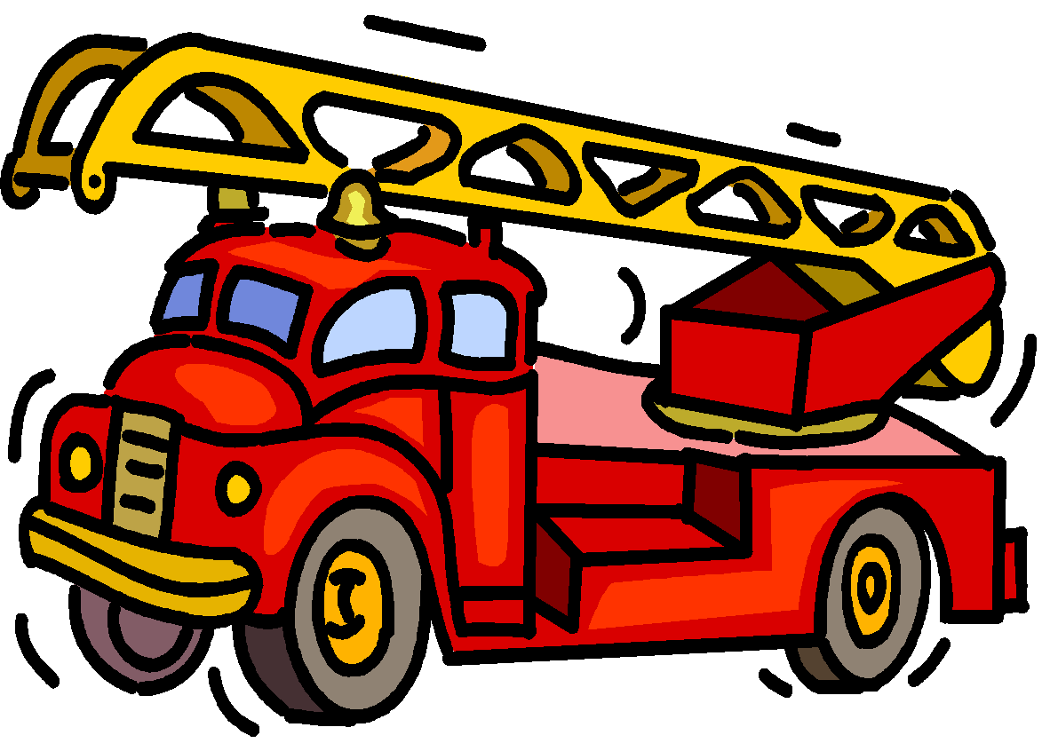

Fire Department Emergency Number –
707-543-3500 or 911

Closest Hospital Number
Petaluma Valley Hospital
707-778-1111
400 N McDowell Blvd,
Petaluma, CA 94954

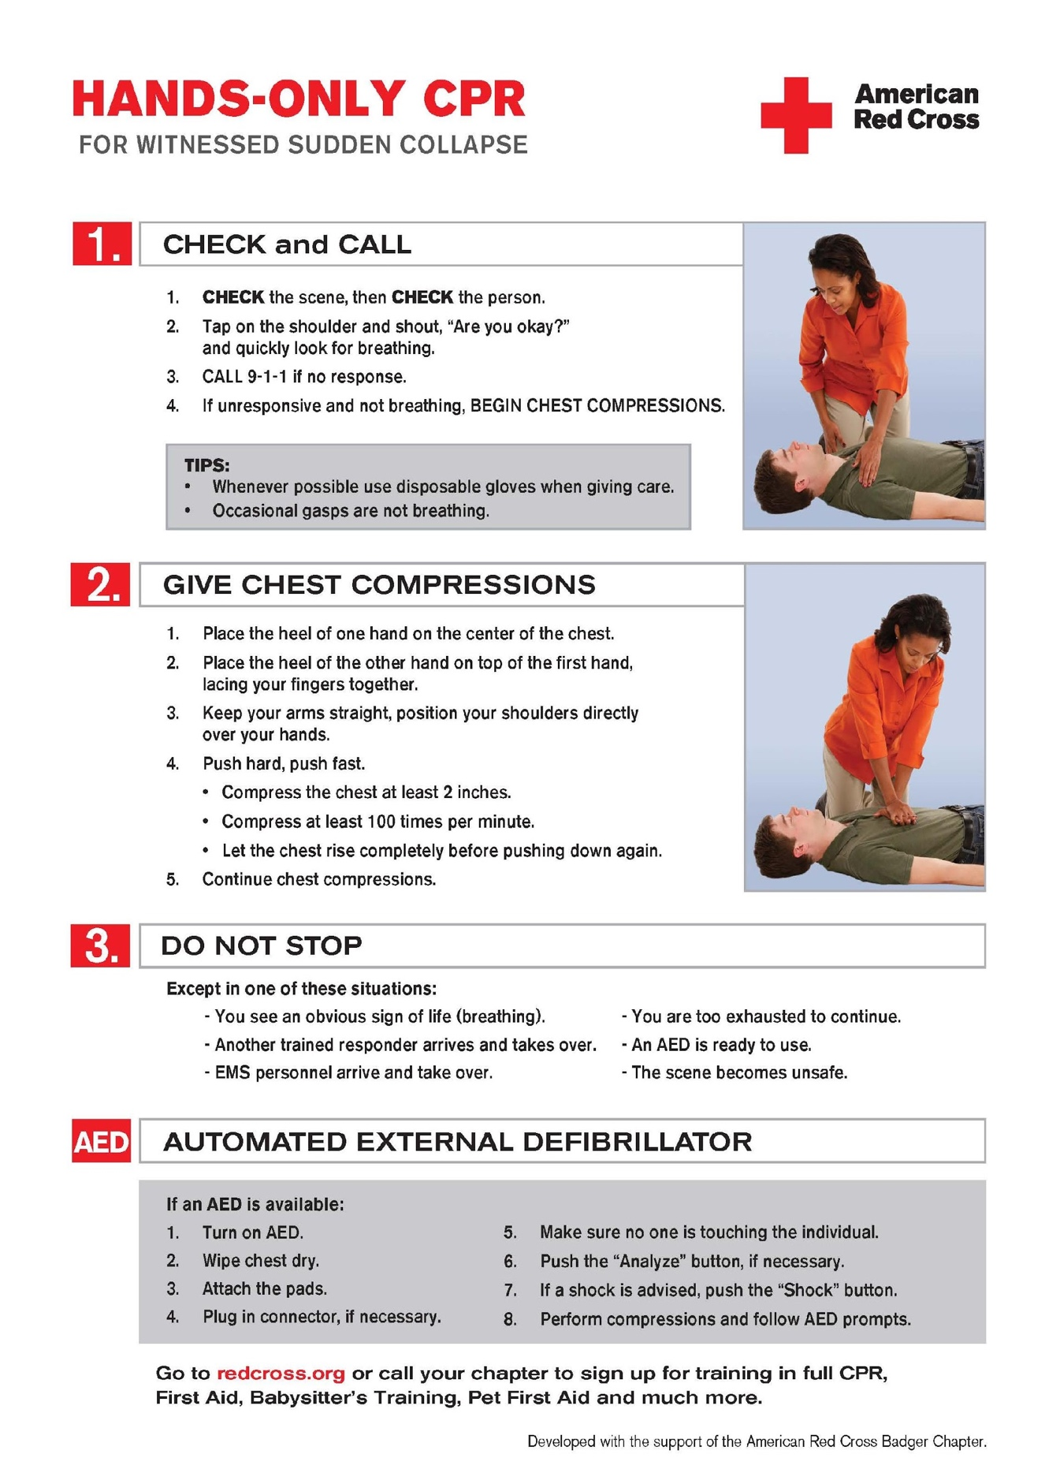
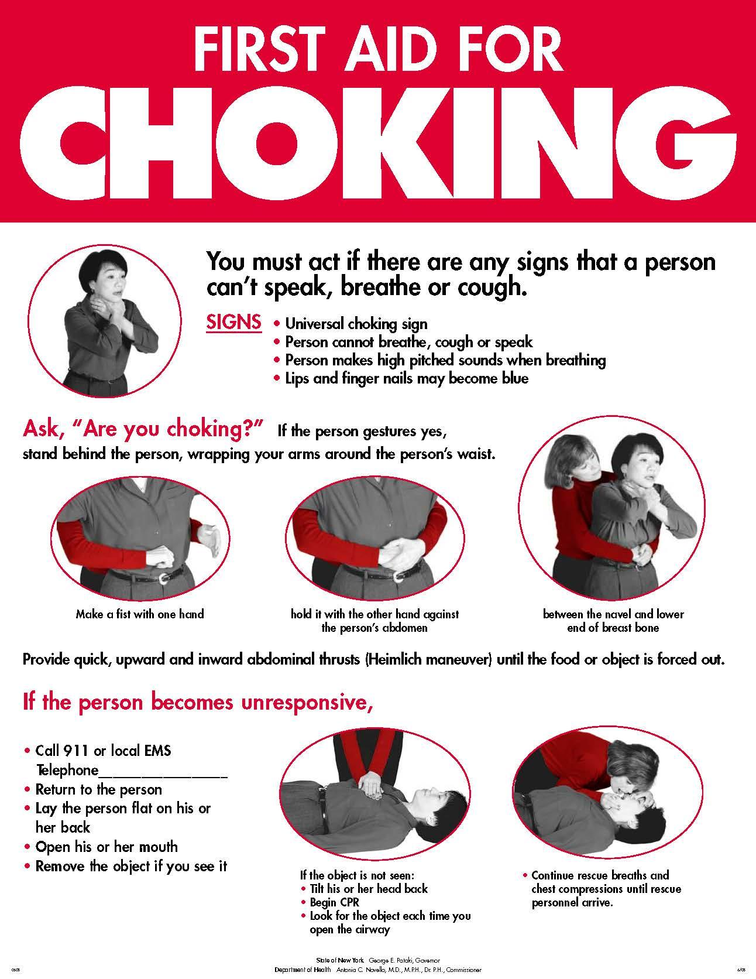
COMMUNICABLE DISEASE PROCEDURES

While risk of one athlete infecting another with HIV/AIDS during competition is close to non-existent, there is a remote risk that other blood born infectious diseases can be transmitted. For example, Hepatitis B can be present in blood as well as in other body fluids. Procedures for reducing the potential for transmission of these infectious agents should include, but not be limited to, the following:

1. The bleeding must be stopped, the open wound covered and if there is an excessive amount of blood on the uniform it must be changed before the athlete may participate. (Any blood on the uniform must be covered, tape is the simplest method)
2. Routine use of gloves or other precautions to prevent skin and mucous-membrane exposure when contact with blood or other body fluids is anticipated.
3. Immediately wash hands and other skin surfaces if contaminated (in contact) with blood or other body fluids. Wash hands immediately after removing gloves.
4. Clean all contaminated surfaces and equipment with an appropriate disinfectant before competition resumes. (If there is blood on the dirt, remove and dispose. If it is on the grass, clean it up)
5. Practice proper disposal procedures to prevent injuries caused by needles, scalpels and other sharp instruments or devices.
6. Although saliva has not been implicated in HIV transmission, to minimize the need for emergency mouth-to-mouth resuscitation, mouthpieces, resuscitation bags, or other ventilation devices should be available for use.
7. Athletic trainers/coaches with bleeding or oozing skin conditions should refrain from all direct athletic care until the condition resolves.
8. Contaminated towels should be properly disposed of/disinfected.
9. Follow acceptable guidelines in the immediate control of bleeding and when handling bloody dressings, mouth guards and other articles containing body fluids.

Every manager needs a gallon size zip lock bag. With 2 sets of gloves and paper towels. Only to be used if there is blood or open wounds. Once the first aid has been given please put gloves and paper towels. In the Ziploc bag and dispose. This will protect everyone.

COVID-19 Guidelines
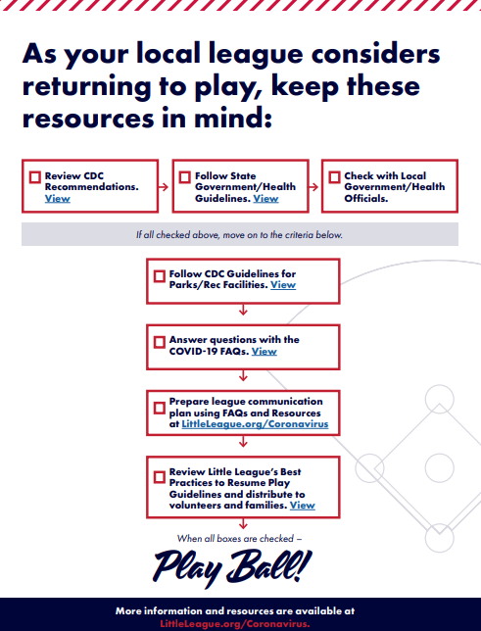

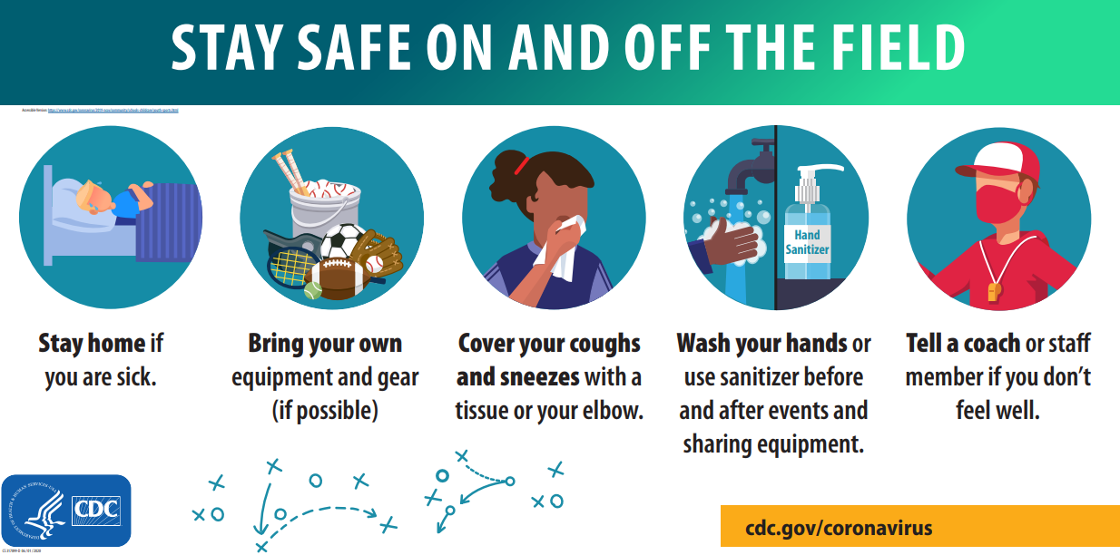

Insert List of your Board of Directors
including contact information

Position | Name | Contact #
President | Chase Parker | 707-732-3853
Vice President | John Busick | 707-933-7822
Secretary | Ashley Kidd | 707-849-1781
Treasurer | Emily Parker | 707-477-8568
Player Agent | Matt Kidd | 707-696-6339
Safety Officer | Brandon Deering | 707-333-4577
Information Officer | Ashley Kidd | 707-849-1781
Equipment Coordinator | Dan Hermsmeyer | 707-328-1469
Field Maintenance | Anthony Beltramo | 707-971-9556
Snack Shack Coordinator | Emily Parker | 707-477-8568
Sponsorship Coordinator | Vincent Morris | 707-799-9630
Coach Coordinator | Chase Parker | 707-732-3853
Umpire Coordinator | Greg Bridges | 707-338-7822
Facilities Coordinator | Logan Savage | 707-703-2205
Volunteer Coordinator | Cathy Corso | 707-217-2346
Fundraising Coordinator | Cathy Corso | 707-217-2346

Concussions in Youth Athletes

The California law is found under the California Education Code (Cal. Educ. Code Section 35179.1 (c)(6), known as the 1998 California High School Coaching Education and Training Program) requires that coaches be certified in CPR and first aid and have a basic understanding of the signs and symptoms of concussions and the appropriate response to concussions. The California law can be found at sections 38131(6) and 49475 of the Education Code. (Cal. Educ. Code § 38131(6)). §674539(b) (Cal. Educ. Code) requires adoption and implementation of guidelines to prevent, assess, and treat sports-related concussions.
The California law provides that if a school district, charter school or private school offers an athletic program, any athlete who is suspected of sustaining a concussion must be removed immediately from the activity for the rest of the day. The student is not permitted to return to activity until cleared in writing by a health care professional. Parents/guardians of any student wishing to participate in an athletic activity are required to annually sign a concussion information sheet before the student can participate. An athletic program is required to adopt and implement guidelines to prevent, assess and treat sports-related concussions. This law also applies to recreational activities taking place on school owned grounds which are not sponsored or part of school run activities.
The official versions of sections 38131(6), 35179.1, 49475, and 67453 are currently available online at:
http://leginfo.legislature.ca.gov/faces/codes_displaySection.xhtml?lawCode=EDC§ionNum=38131.
http://leginfo.legislature.ca.gov/faces/codes_displaySection.xhtml?lawCode=EDC§ionNum=35179.1.
http://leginfo.legislature.ca.gov/faces/codes_displaySection.xhtml?lawCode=EDC§ionNum=49475.
http://leginfo.legislature.ca.gov/faces/codes_displaySection.xhtml?lawCode=EDC§ionNum=67453.

We can help athletes stay active and healthy by knowing the facts about concussion and when it is safe for athletes to return to play.
Concussion training will help to
- Understand a concussion and potential consequences of this injury
- Recognize concussion signs and symptoms and how to respond
- Learn steps for returning to play after a concussion
- Focus on prevention and preparedness to help keep athletes safe

Concussion training and education for Coaches, Parents, Athletes, and Sports Officials can be found at:
https://www.cdc.gov/headsup/youthsports/training/index.html

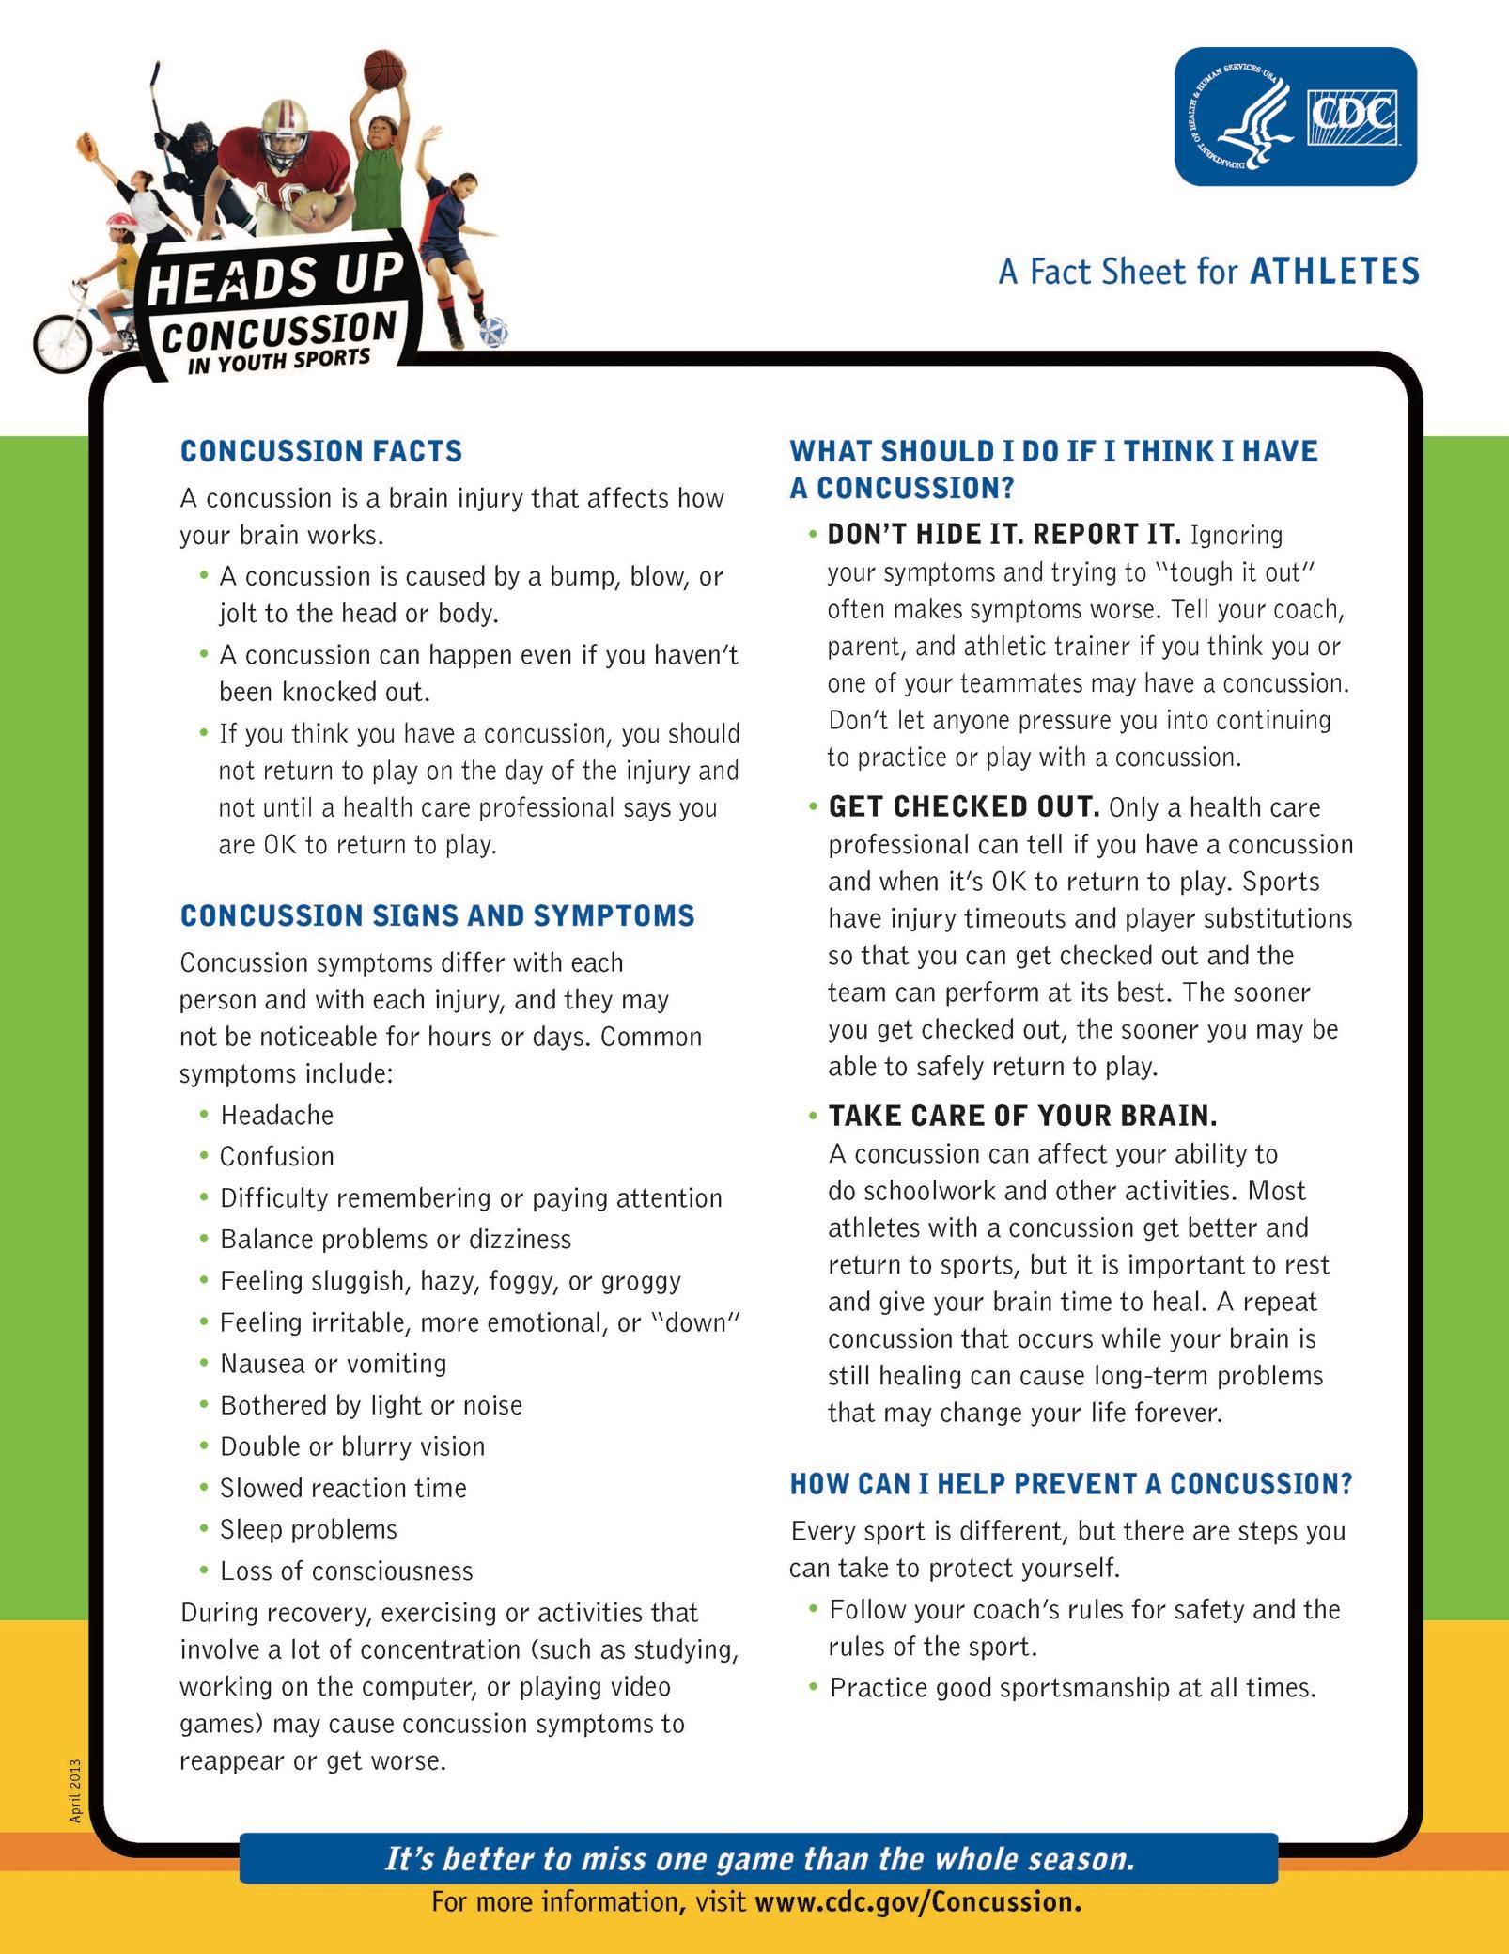
Petaluma American Little League
Concussion Prevention, Treatment and Management Policy
The Legislature enacted a law which requires youth sports organizations to adopt a policy concerning the prevention and treatment of injuries to the head which may occur during a youth’s participation in competitive sports, including, without limitation, a concussion of the brain.
A concussion is a brain injury that results from a bump, blow or jolt to the head or body which causes the brain to move rapidly in the skull and which disrupts normal brain function. The Centers for Disease Control and Prevention of the United States Department of Health and Human Services estimates that as many as 3.8 million concussions occur each year in the United States which are related to participation in sports and other recreational activities. Athletes who continue to participate in an athletic activity while suffering from a concussion or suffering from the symptoms of an injury to the head are at greater risk for catastrophic injury to the brain or even death. Ensuring that a Little League player who sustains or is suspected of sustaining a concussion or other injury to the head receives appropriate medical care before returning to baseball activity will significantly reduce the child’s risk of sustaining greater injury in the future.
THEREFORE, Petaluma American Little League hereby adopts the following policy for purposes of prevention, treatment, and management of injuries to the head that may occur during a player’s participation in the Little League program, including, without limitation, a concussion of the brain:
1. Prior to a team’s first practice each season, every manager, coach, and adult assistant shall:
a) Familiarize themselves with the CDC publication “Heads Up – Concussion in Youth Sports – A Fact Sheet for Coaches”. This publication will be provided to all such individuals by the League Safety Officer or other Board members; and,
b) Complete the CDC on-line training course at:
https://www.train.org/cdctrain/course/1089818/
A copy of the Certificate of Completion for each of the above individuals shall be submitted to the League Safety Officer.
2. If a Little League player sustains, or is suspected of sustaining, an injury to the head while participating in any Little League game or even the player must:
a. Be immediately removed from the game or event; and
b. May only return to Little League activity if the parent or legal guardian of the player provides a signed statement from a provider of health care indicating that the youth is medically cleared for Little League participation and the date on which the player may return to participation.
3. The Little League player and his or her parent or legal guardian must sign the statement below acknowledging that they have read and understand the terms and conditions of the policy and agree to be bound by the policy.
Petaluma American Little League Concussion Prevention, Management and Treatment Policy
Player and Parental Acknowledgement
We, the undersigned, acknowledge that we have been provided with a copy of the Petaluma American Little League Concussion Prevention, Management and Treatment Policy, and that we have read and understand the policy, or it has been read to us and we understand the same. We hereby agree to follow all procedures set forth in said Policy at all times during which our son or daughter participates in Little League activities and events.
Dated: ___________________ _________________________
Player
Dated: ___________________ _________________________ _________________________
Parent/Legal Guardian Parent/Legal Guardian
LEAGUE USE: Division: ____________ Team: ____________

FIRE SAFETY
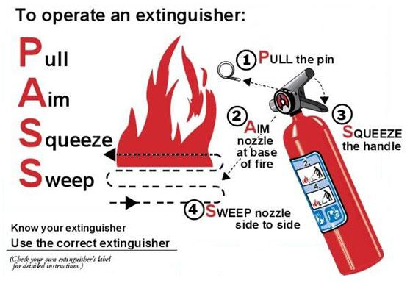

Date Serviced 2/11/2022 Location- Major Snack Shack (1)

Date Serviced 2/11/2022 Location- 2nd Floor Office /Announcers Booth (1)

Date Serviced 2/11/2022 Location- Equipment Shed (1)

Date Serviced 2/11/2022 Location- Kenneally Snack Shack (1)

DRUG AWARENESS

A drug is any substance that alters the body’s chemistry. Drug abuse and addiction can happen to anyone, at any age. Drugs abuse does not respect the age of its victim.

National Statistics indicate the Alcohol is one of the most widely used drug substances in the world. Alcohol use and binge drinking among our nation’s youth is a major public health problem.

Additionally, the numbers of youth experimenting and using illicit drugs is increasing. The non-medical use of prescription drugs among youth is on a steady incline.

Coaches and parents should be alert to the warning signs of warning signs for youth *:

1. Drop in academic performance

2. Lack of interest in personal appearance

3. Withdrawal, isolation, depression, fatigue

4. Aggressive, rebellious behavior

5. Hostility and lack of cooperativeness

6. Deteriorating relationships with family

7. Change in friends

8. Loss of interest in hobbies and/or sports

9. Change in eating/sleeping habits

10. Evidence of drugs or drug paraphernalia (e.g., needles, pipes, papers, lighters).

11. Physical changes (e.g., runny nose not from cold, red eyes, coughing, wheezing,
bruises, needle marks)

Source D.A.R.E

LEAGUE SAFETY CODE

The Board of Directors of our Little League has mandated the following Safety Code. All managers and coaches will read this Safety Code and then discuss it with the players on their team.

- Responsibility for safety procedures belongs to every adult member of our Little League.

- Each player, manager, designated coach, umpire, team safety officer shall use proper reasoning and care to prevent injury to him/herself and to others.

- Only league approved managers and/or coaches are allowed to practice teams.

- Only league-approved managers and/or coaches will supervise batting Cages.

- Arrangement should be made in advance of all games and practices for emergency medical services.

- Managers, designated coaches and umpires will have mandatory training in First Aid.

- First-aid kits are issued to each team manager during the pre-season and additional kits will be located at each Snack Bar.

- No games or practices will be held when weather or field conditions are poor, particularly when lighting is inadequate.

- Play area will be inspected before games and practices for holes, damage, stones, glass and other foreign objects.

- Team equipment should be stored within the team dugout or behind screens, and not within the area defined by the umpires as “in play.” No bat handle will be hung on the inside or outside of the screens that face the field of play.

- Only players, managers, coaches and umpires are permitted on the playing field or in the dugout during games and practice sessions.

- Shoes with metal spikes or cleats are not permitted, except at the 50/70 Baseball and above. Shoes with molded cleats are permissible.

- Disengage-able bases are mandatory for ALL league fields.

- Players will not wear watches, rings, pins, jewelry or other metallic items during practices or games. (Exception: Jewelry that alerts medical personnel to a specific condition is permissible and this must be taped in place.)

- No food or drink, at any time, in the dugouts. (Exception: bottled water, Gatorade and water from drinking fountains)

- All catchers must wear a mask, “dangling” type throat protector and catcher’s helmet during practice, pitcher warm-up, and games. Note: Skullcaps are not permitted.

- Catchers must wear a catcher’s mitt (not a first baseman’s mitt or fielder’s glove) of any shape, size or weight consistent with protecting the hand.

- Managers and coaches will never leave an unattended child at a practice or game.

- No children under the age of 14 are permitted in the Snack Bar.

- Never hesitate to report any present or potential safety hazard to the Safety Officer immediately.

- Make arrangements to have a cellular phone available when a game or practice is at a facility that does not have public phones.

- NO ALCOHOL OR DRUGS ALLOWED AT ANY OF OUR FACILITIES OR FIELDS, ANY TIME.

- No medication will be taken at the facility unless administered directly by the child’s parent. This includes aspirin and Tylenol.

- No playing in the parking lots at any time.

- No playing on and around lawn equipment, machinery at any time.

- NO SMOKING OR TOBACCO PRODUCTS ALLOWED AT ANY OF OUR FACILITIES OR FIELDS.

- All pre-game warm-ups will be performed within the confines of the playing field and not within areas frequented by spectators.

- No hitting hardballs against the fences. Whiffle balls only may be used for this purpose of soft toss.

- No climbing fences.

- Players will stay inside the dugout during the game and not sit or stand in the door opening. Managers and coaches will stay in the dugout or entirely behind the screen if available. No one will sit on buckets or squat at the doorway.

- Pets must be on a leash if allowed.

- Observe all posted signs.

- Players and spectators should be alert at all times for foul balls and errant throws.

- All gates to the fields must remain closed at all times. After players have entered or left the playing field, gates should be closed and secured.

- Bicycle helmets must be worn at all times when riding bicycles on the premises as well as to and from the premises.

- Use crosswalks when crossing roadways. Always be alert for traffic.

- There is no running allowed in the bleachers.

- Adults will not allow the players to carry team equipment bags.

- Youth umpires under age 18 will be required to wear a mask with dangling guard while behind the plate.

- Spotters must wear a helmet.

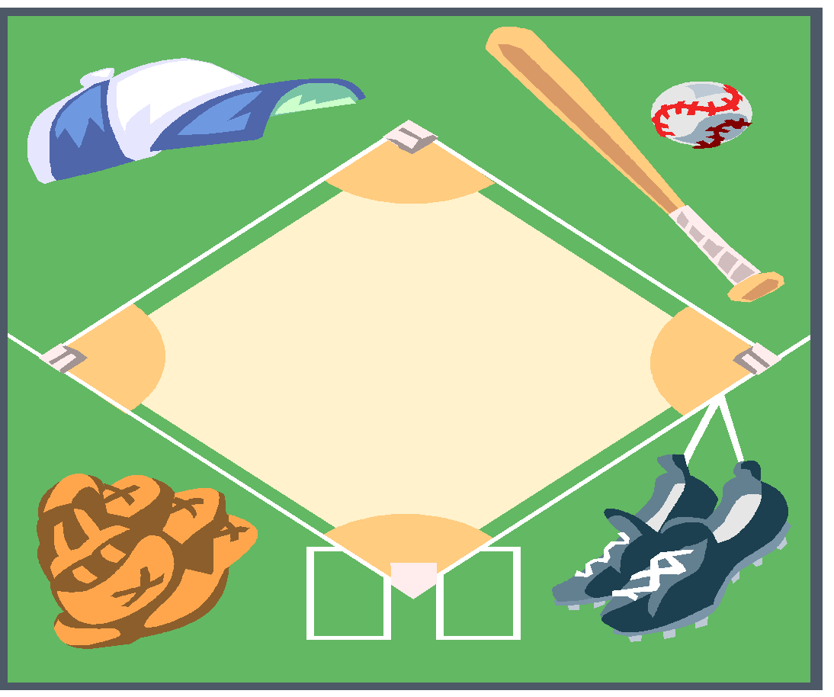

SAFETY RESPONSIBILITIES
The President:
The President of our league is responsible for ensuring that the policies and regulations of the League’s Safety Officer are carried out by the entire membership to the best of his abilities.

Safety Officer:
The main responsibility of the Safety Officer is to develop and implement our League’s safety program. The Safety Officer is the link between the Board of Directors of our Little League and its managers, coaches, umpires, team safety officers, players, spectators, and any other third parties on the complex in regards to safety matters, rules and regulations.

The Safety Officer’s responsibilities include:
Coordinate with the Team Safety Officers to provide the safest environment possible for all.
- Preparing and updating the League’s Safety Plan/ Facility Safety Survey
- Assisting parents and individuals with insurance claims and will act as the liaison between the insurance company and the parents and individuals.
- Explaining insurance benefits to claimants and assisting them with filing the correct paperwork.
- Keeping the First Aid Log. This log will list where accidents and injuries are occurring, to whom, in which divisions (senior, major, minor, tee ball), at what times, under what supervision.
- Correlating and summarizing the data in the First-Aid Log to determine proper accident prevention in the future.
- Insuring that each team receives its Safety Manual and its First-Aid Kit at the beginning of the season.
- Installing First-Aid Kits in all concession stands and the clubhouse and re-stocking the kits as needed.
- Make Little League’s “no tolerance with child abuse” clear to all.
- Inspecting concession stands and checking fire extinguishers.
- Instructing Snack Bar workers on the use of fire extinguishers.
- Checking fields with the Field Managers and listing areas needing attention.
- Scheduling and attending First-Aid Clinics and CPR training classes for managers, designated coaches, umpires, player agents and team safety officers during the pre-season.
- Demonstrate the use and location of the AED
- Creating and maintaining all signs on the fields and facilities including No Parking signs, No Smoking signs, No Pets Allowed, cautionary signs
- Acting immediately in resolving unsafe or hazardous conditions once a situation has been brought to his/her attention.
- Making spot checks at practices and games to make sure all managers have their First-Aid Kits and Safety Manuals.
- Tracking all injuries and near misses in order to identify injury trends.
- Visiting other leagues to allow a fresh perspective on safety.
- Making sure that safety is a monthly Board Meeting topic, and allowing experienced people to share ideas on improving safety.

The League Members:
The League Members will adhere to and carry out the policies as set forth in this safety manual.

The League Information Officer:
The League Information Officer is responsible for maintaining the website and updating the safety information on a weekly basis.

The League Player Agent:
The League Player Agent is responsible for the collection of player registration, manager and coach data. The Player Agent will submit the data to Little League Data Center at www.littleleague.org.

Managers and Coaches:
The Manager is a person appointed by the president to be responsible for the team’s actions on the field, and to represent the team in communications with the umpire and the opposing team.

- The Manager will always be responsible for the team’s conduct, observance of the official rules and deference to the umpires. Remember coaches are Role Models.
- The Manager is also responsible for the safety of his players. He/She is also ultimately responsible for the actions of designated coaches and the Team Safety Officer (TSO).
- If a Manager leaves the field, that Manager will designate a Coach as a substitute and such Substitute Manager shall have the duties, rights and responsibilities of the Manager.

Pre-Season:
Managers will:
- Take possession of the current Safety Manual and the supplied First-Aid Kit.
- Appoint a Team Safety Officer (TSO).
- The TSO must be able to be present at all games and must own or have access to a cell phone for emergencies if games or practices take place off the main complex.
- Attend a mandatory training session on First Aid given by the League with his/her designated coaches and TSO.
- Have a team meeting to discuss Little League philosophy and safety issues.
- Cover the basics of safe play with his/her team before starting the first practice.
- Teach players the fundamentals of the game while advocating safety.
- Teach players how to slide before the season starts. A coach coordinator can be available to teach these fundamentals if the Manager or designated coaches do not know them.
- Notify parents that if a child is injured or ill, he or she cannot return to practice unless they have a note from their doctor. This medical release protects you if that child should become further injured or ill. There are no exceptions to this rule.
- Encourage players to bring water bottles to practices and games.
- Tell parents to bring sunscreen for themselves and their child.
- Encourage your players to wear mouth protection.
Season Play:
Managers will:
- Work closely with Team Safety Officer to make sure equipment is in first-rate working order.
- Make sure that telephone access is available at all activities including practices. It is suggested that a cellular phone always be on hand.
- Not expect more from their players than what the players are capable of.
- Teach the fundamentals of the game to players.
- Catching fly balls
- Sliding correctly
- Proper fielding of ground balls
- Simple pitching motion for balance
- Be open to ideas, suggestions or help.
- Enforce that prevention is the key to reducing accidents to a minimum.
- Have players wear sliding pads if they have cuts or scrapes on their legs.
- Always have First-Aid Kit and Safety Manual on hand.
- Use common sense.

Pre-Game and Practice:
Managers will:
- Make sure that players are healthy, rested and alert.
- Make sure that players returning from being injured have a medical release form signed by their doctor. Otherwise, they can’t play.
- Make sure players are wearing the proper uniform and catchers are wearing a cup.
- Make sure that the equipment is in good working order and is safe.
- Agree with the opposing manager on the fitness of the playing field. In the event that the two managers cannot agree, a duly delegated representative shall make the determination.
- Enforce the rule that no bats and balls are permitted on the field until all players have done their proper stretching.
1. Calf muscles 2. Hamstrings 3. Quadriceps
4. Groin. 5. Back 6. Shoulders
7. Elbow/forearm. 8. Arm shake out 9. Neck

Then have players do a light jog around the field before starting throwing warm-ups that should follow this order.
- Light tosses short distance.
- Light tosses medium distance.
- Light tosses large distance.
- Medium tosses medium distance.
- Regular tosses medium distance.
- Field ground balls.
- Field pop flies

During the Game
Managers will:
- Make sure that players carry all gloves and other equipment off the field and to the dugout when their team is up at bat.
- No equipment shall be left lying on the field, either in fair or foul territory.
- Keep players alert.
- Maintain discipline at all times.
- Be organized.
- Keep players and substitutes sitting on the team’s bench or in the dugout unless participating in the game or preparing to enter the game.
- Make sure catchers are wearing the proper equipment.
- Encourage everyone to think Safety First.
- Observe the “no on-deck” rule for batters and keep players behind the screens at all times. No player should handle a bat in the dugouts at any time.
- Keep player’s off fences.
- Keep players out of bullpen unless they are pitcher and catcher in the proper gear getting warmed up to enter the game.
- Get players to drink often so they do not dehydrate.
- Not play children that are ill or injured.
- Attend to children that become injured in a game.
- Not lose focus by engaging in conversation with parents and passerby’s.
If a Manager has not appointed a Team Safety Officer then he or she must assume those responsibilities.

Post-Game
Managers will:
- Do cool down exercises with the players.
    - Stretching as noted above.
    - Light jog
    - Those who throw regularly (pitchers and catchers) should ice their shoulders and elbows.
    - Catchers should ice their knees.
- Not leave the field until every team member has been picked up by a known family member or designated driver.
- Notify parents if their child has been injured no matter how small or insignificant the injury is. There are no exceptions to this rule. This protects you, Little League Baseball, Incorporated and our local league.
- Discuss any safety problems with the Team Safety Officer that occurred before, during or after the game.
- If there was an injury, make sure an accident report was filled out and given to the League Safety Officer.
- Return the field to its pre-game condition, per League policy.
If a manager knowingly disregards safety, he/she will come before the League’s Board of Directors to explain his or her conduct.

Pre-Season Training Dates
Safety Officer Training
One of the responsibilities of the District 35 Safety Officer is to conduct a Safety Officer Training Seminar. This training seminar is intended to train the League Safety Officers in how to keep their leagues safe and how to prepare the ASAP Safety Plan. All League Safety Officer are required to attend this training.

The D35 Safety Officer Training is scheduled for:
January 12th, 2022

First Aid Training
It is the responsibility of the league Safety Officer to train all Managers and Coaches, as well as any volunteers are determined by the individual leagues in how to provide first aid to injured individuals.

The League First Aid Training is scheduled for: February 26th, 2022
_______________

Coaching Fundamentals Training
Each league is required to train Managers and Coaches in the fundamentals of baseball. The purpose of this training is to establish proper baseball techniques through Coaching while advocating safety.

The Fundamentals Training is scheduled for: February 26th, 2022

_________________
Basic Batting Cage Guidelines

- Adult supervision is required at all times when the batting cage is in use.

- If a pitching machine is used to deliver the balls, the pitching machine must be operated by an adult.

- The pitching machine should be turned off when retrieving balls in the cage.

- When using a pitching machine making sure the ground is level and the pitching machines legs are properly stabilized.

- Only one batter and one pitcher/pitching machine operator are allowed in the cage at a time.

- “Practice Swings” immediately outside the cage should not be permitted.

- The pitcher/pitching machine operator must use an “L” fence protector.

- Lock/secure the batting cage at all times when not being used by the league.

- Enforce approved helmet use for everyone in the batting cage; hitters and pitchers.
(Recommended for adults operating the pitching machine as well)

10. Place second fence or barrier around the batting cage at a safe distance to keep people from being struck by balls hit into the netting, causing the netting to flare out.
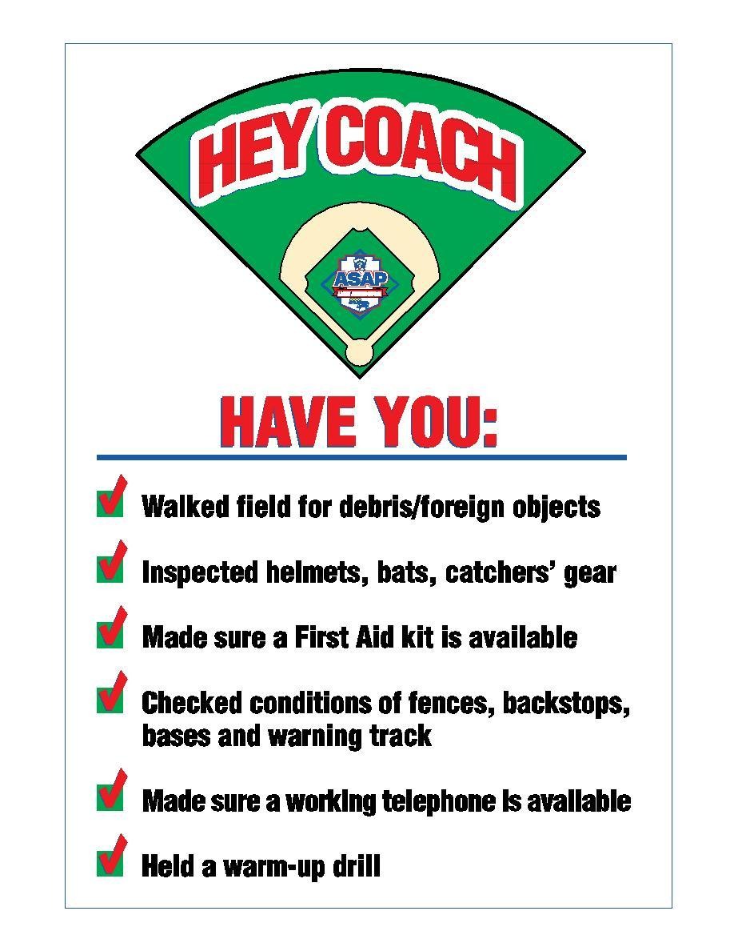

Umpires

Pre-Game
Before a game starts, the umpire shall:
- Check equipment in dugouts of both teams, equipment that does not meet specifications must be removed from the game.
- Make sure catchers are wearing helmets when warming up pitchers.
- Run hands along bats to make sure there are no slivers.
- Make sure that bats have grips.
- Make sure there are foam inserts in helmets and that helmets meet Little League NOCSAE specifications and have the Little League’s seal of approval.
- Inspect helmets for cracks.
- Walk the field for hazards and obstructions (e.g. rocks and glass).
- Check players to see if they are wearing jewelry.
- Check players to see if they are wearing metal cleats.

During the Game:
During the game the umpire shall:
- Govern the game as mandated by Little League rules and regulations.
- Check baseballs for discoloration and nicks and declare a ball unfit for use if it exhibits these traits.
- Act as the sole judge as to whether and when play shall be suspended or terminated during a game because of unsuitable weather conditions or the unfit condition of the playing field; as to whether and when play shall be resumed after such suspension; and as to whether and when a game shall be terminated after such suspension.
- Act as the sole judge as to whether and when play shall be suspended or terminated during a game because of low visibility due to atmospheric conditions or darkness.
- Enforce the rule that no spectators shall be allowed on the field during the game.
- Make sure catchers are wearing the proper equipment.
- Continue to monitor the field for safety and playability.
- Make the calls loud and clear, signaling each call properly.
- Make sure players and spectators keep their fingers out of the fencing.

Post-Game:
After a game, the umpire shall:
- Report any unsafe situations to the League Safety Officer by telephone and in writing.

League Field Supervisor:
The Field Supervisor is responsible to ensure the fields and structures used by the League meet the safety requirements as set forth in this manual. (Adult Game Coordinator 9.03d)

League Equipment Officer:
The League Equipment Officer is responsible to get damaged equipment repaired or replaced as reported. This replacement will happen in a timely manner. The Equipment Manager will also exchange equipment if it doesn’t fit properly.

Team Safety Officer (TSO):
The TSO is a Role model to younger children, Defender of safety, Liaison between the team and the League Safety Officer, Hero when taking safety seriously prevents injuries.
Pre-Season
In the pre-season, the TSO must:
- Acquire this Safety Manual from the team manager and read it.
- Call the League Safety Officer and introduce yourself.
- Attend the Emergency Medical Clinic with your team manager.
- Have parents fill out Emergency Medical Treatment Consent and
- Contact forms and return them to you. (photocopy sample in the appendix)
- Inspect the equipment when the Equipment Manager issues it to your team and replace any equipment that looks unsafe.
- Get to know the players on your team.
- Talk to parents, confidentially, and inquire if their child suffers from allergies, asthma, heart conditions, past injuries, ADD, ADHD, a communicable disease such as hepatitis, HIV, AIDS, etc. Fill out a medical history form on each child (see sample in appendix)
- Find out if a child is taking any kind of medication.
- Report your findings in a written summary and submit it to the League Safety Officer.
- Safety Officer for his/her records.

During the Season
During the season, the TSO will:
- Keep a Safety Log of all injuries that occur on his or her team.
- Report weekly as part of a Safety Committee to the League Safety Officer even if nothing is wrong.
- Inspect players’ equipment for cracks and broken straps on a routine basis.
- Have a five-minute safety meeting with the team each week.
- Communicate any safety infractions to the League Safety Officer or any other Board Member.
- Have parents fill out “driving permission slips” if transporting a child to a game or practice is necessary.
- Help managers and designated coaches give First-Aid if needed.
- Act as a conduit between parents, managers, the League Safety Officer and the kids.
- Fill out accident reports if an injury occurs, Report an injury to the League Safety Officer within 24 hours of the occurrence.
- Track the First-Aid Kit inventory and ask the League Safety Officer for replacements when needed.

Pre-Game
Before the game starts the TSO will:
- Make sure that this Safety Manual and the First-Aid Kit are present.
- Maintain a copy of the current Safety Manual.
- Greet the players as they arrive and make sure everyone is feeling all right.
- Watch the players when they stretch and do warm up exercises for signs of stress or injury.
- Check equipment for cracks and broken straps.
- Walk the field remove broken glass and other hazardous materials.
- Be ready to go into action if anyone should get hurt.

During the Game
During the game the TSO will:
- Watch players to see that they are alert at all time.
- In case of injury, help the team manager treat the child until profession help arrives.
- Act as the conduit between the League Safety Officer, the team manager, the child and his or her parents.

Post-Game
After the game the TSO will:
- Record any safety infractions or injuries in his/her Safety Log.
- Report any injuries to the League Safety Officer within 12 hours of the occurrence.
- Fill out an accident investigation report (see appendix) and send a copy to the League Safety Officer if there is an injury requiring medical attention.
- Assist parents if child must go to a hospital or to see a doctor.
- Provide insurance documentation to the hospital if necessary (Claim form is in the appendix with all necessary insurance information).
- Follow-up with parents to make sure the child is all right.

If a Manager has not appointed a Team Safety Officer
then he or she must assume those responsibilities.

Post-Season Play
All Star Play:
Everybody’s responsibilities remain the same throughout the post-season. This includes TOC and All Stars.

CONDITIONING & STRETCHING

Conditioning is an intricate part of accident prevention. Extensive studies on the effect of conditioning, commonly known as “warm-up,” have demonstrated that:

- The stretching and contracting of muscles just before an athletic activity improves general control of movements, coordination and alertness.
- Such drills also help develop the strength and stamina needed by the average youngster to compete with minimum accident exposure.

The purpose of stretching is to increase flexibility within the various muscle groups and prevent tearing from overexertion.

Stretching should never be done forcefully, but rather in a gradual manner to encourage looseness and flexibility.
Hints on Stretching
- Stretch necks, backs, arms, thighs, legs and calves.
- Don’t ask the child to stretch more that he or she is capable of.
- Hold the stretch for at least 10 seconds.
- Don’t allow bouncing while stretching. This tears down the muscle rather than stretching it.
- Have one of the players lead the stretching exercises.

Hints on Calisthenics
- Repetitions of at least 10.
- Have kids synchronize their movements.
- Vary upper body with lower body.
- Keep the pace up for a good cardiovascular workout.

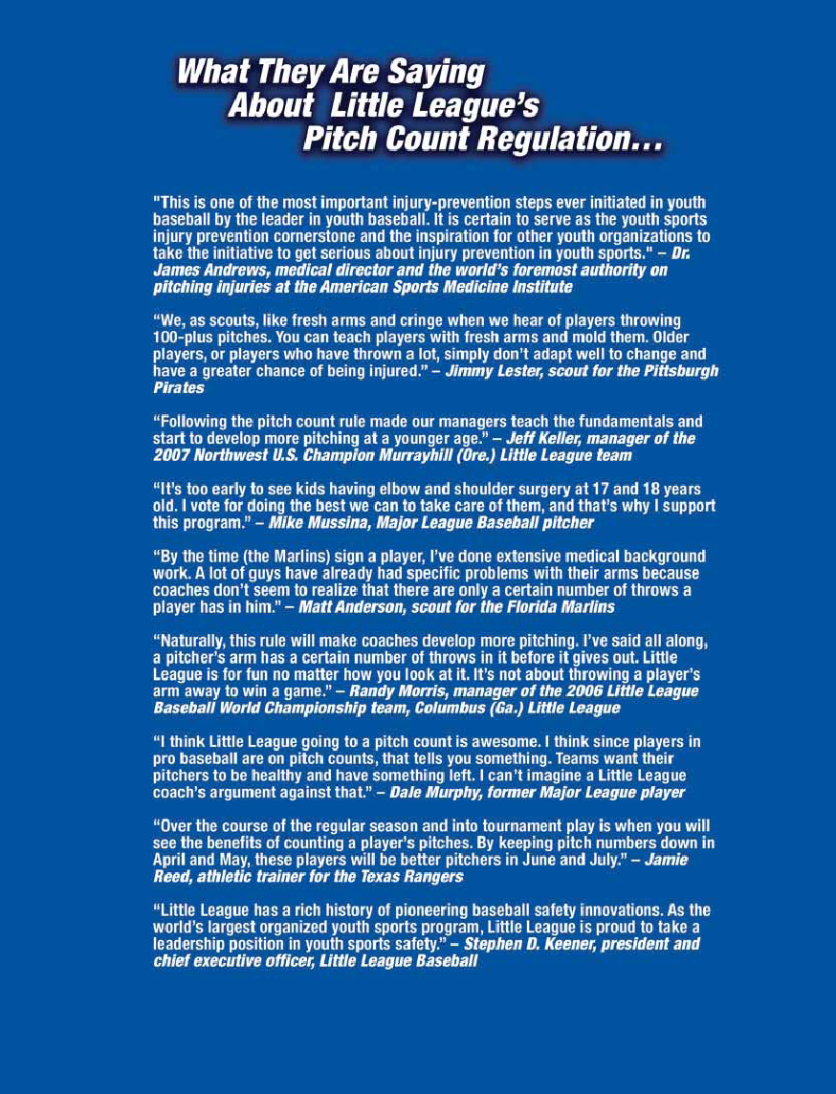
PITCH COUNT
Pitch count does matter.
Every year, at our annual First-Aid clinic, we provide warnings to our future managers and coaches about pitching injuries and how to prevent them.

A child cannot be expected to perform like an adult!
Little League managers and coaches are usually quick to teach their pitchers how to get movement on the ball. Unfortunately, the technique that older players use is not appropriate for children thirteen (13) years and younger. The snapping of the arm used to develop this technique will most probably lead to serious injuries to the child as he/she matures. Arm stress during the acceleration phase of throwing affects both the inside and the outside of the growing elbow. On the inside, the structures are subjected to distraction forces, causing them to pull apart. On the outside, the forces are compressive in nature with different and potentially more serious consequences. The key structures on the inside (or medial) aspect of the elbow include the tendons of the muscles that allow the wrist to flex and the growth plate of the medial epicedial (“Knobby” bone on the inside of the elbow). The forces generated during throwing can cause this growth plate to pull away (avulse) from the main bone. If the distance between the growth plate and main bone is great enough, surgery is the only option to fix it. This growth plate does not fully adhere to the main bone until age 15! Similarly, on the outside of the elbow the two bony surfaces can be damaged by compressive forces during throwing. This scenario can lead to a condition called Avascular Necrosis or Bone Cell Death as a result of compromise of the local blood flow to that area. This disorder is permanent and often leads to fragments of the bone breaking away (loose bodies), which float in the joint and can cause early arthritis. This loss of elbow motion and function often precludes further participation.

Studies have demonstrated that curveballs cause most problems at the inside of the elbow due to the sudden contractive forces of the wrist musculature. Fastballs, on the other hand, place more force at the outside of the elbow. Sidearm delivery, in one study, led to elbow injuries in 74% of pitchers compared with 27% in pitchers with a vertical delivery style. The American Sports Medicine Institute has completed a study funded by USA Baseball that evaluated pitch counts in skeletally immature athletes as they relate to both elbow and shoulder injuries.
DATA HAS SHOWN THE FOLLOWING:
- A significantly higher risk of elbow injury occurred after pitchers reached 50 pitches/outing.
- A significantly higher risk of shoulder injury occurred after pitchers reached 75 pitches/outing.
- In one season, a total of 450 pitches or more led to cumulative injury to the elbow and the shoulder.
- The mechanics, whether good or bad, did not lead to an increased incidence of arm injuries.
- The preliminary data suggest that throwing curveballs increases risk of injury to the shoulder more so than the elbow; however, subset analysis is being undertaken to investigate whether or not the older children were the pitchers throwing the curve.
- The pitchers who limited their pitching repertoire to the fastball and change-up had the lowest rate of injury to their throwing arm.
- A slider increased the risk of both elbow and shoulder problems.
Proper HYDRATION

Good nutrition is important for children. Sometimes, the most important nutrient children need is water – especially when they’re physically active. When children are physically active, their muscles generate heat thereby increasing their body temperature. As their body temperature rises, their cooling mechanism - sweat – kicks in. When sweat evaporates, the body is cooled.

The California Climate reaches the 100’s during our season. Unfortunately, children get hotter than adults during physical activity and their body’s cooling mechanism is not as efficient as adults. If fluids aren’t replaced, children can become overheated.

We usually think about dehydration only in the summer months when hot temperatures shorten the time it takes for children to become overheated. But keeping children well hydrated is just as important in the winter months.

Additional clothing worn in the colder weather makes it difficult for sweat to evaporate, so the body does not cool as quickly. It does not matter if it’s January or July, thirst is not an indicator of fluid needs. Therefore, children must be encouraged to drink fluids even when they don’t feel thirsty. Managers and coaches should schedule drink breaks every 15 to 30 minutes during practices on hot days, and should encourage players to drink between every inning.

During any activity water is an excellent fluid to keep the body well hydrated. It’s economical too! Offering flavored fluids like sport drinks or fruit juice can help encourage children to drink. Sports drinks should contain between 6 and 8 percent carbohydrates (15 to 18 grams of carbohydrates per cup) or less. If the carbohydrate levels are higher, the sports drink should be diluted with water. Fruit juice should also be diluted (1 cup juice to 1 cup water). Beverages high in carbohydrates like undiluted fruit juice may cause stomach cramps, nausea and diarrhea when the child becomes active. Caffeinated beverages (tea, coffee, Colas) should be avoided because they are diuretics and can dehydrate the body further. Avoid carbonated drinks, which can cause gastrointestinal distress and may decrease fluid volume.
Managers and Coaches should look to their players’ future and make an effort to protect their elbows against the tragedy of Avascular Necrosis.

Before: Drink 8 oz. immediately before exercise
During: Drink at least 4 oz. every 20 minutes
After: Drink 16 oz. for every pound of weight lost
Dehydration signs: Fatigue, flushed skin, light-headed
What to do: Stop exercising, get out of sun, drink
Severe signs: Muscle spasms, clumsiness, delirium

COMMON SENSE

Playing safe boils down to using common sense.
For instance, if you witnessed a strange person walking around the any of our facilities who looked like he/she didn’t belong there you would report the incident to a Board Member.

There will always be a Board Member on site (see the telephone number list in the beginning of this manual to identify them or check the display cases outside the clubhouse).

The Board Member, after hearing your concerns, would investigate the matter and have the person in question removed before anything could happen if, indeed, that person did not belong there.

Another example of common sense
You witness kids throwing rocks or batting rocks on the complex. They are having fun but are unknowingly endangering others. Don’t just walk on by figuring that someone else will deal with the situation. Stop and explain to the kids what they are doing wrong and ask them to stop.

Webster’s Dictionary definition of common sense
Native good judgment; sound ordinary sense.

In other words, to use common sense is to realize the obvious.

Therefore, if you witness something that is not safe, do something about it!
And encourage all volunteers and parents to do the same.

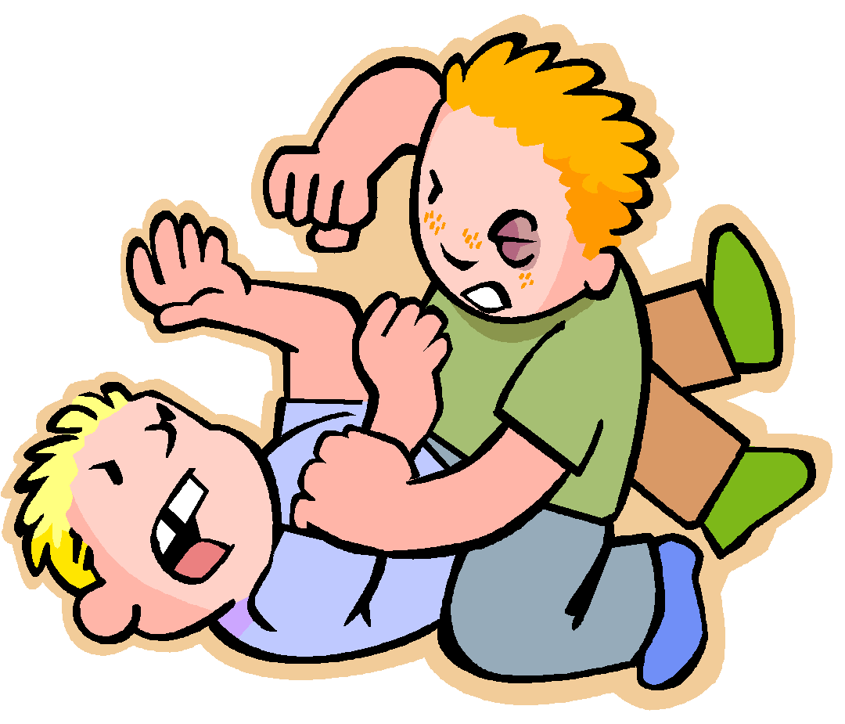

EQUIPMENT

The Equipment Officer is an elected Board Member and is responsible for purchasing and distributing equipment to the individual teams. This equipment is checked and tested when it is issued but it is the Manager’s responsibility to maintain it. Managers should inspect equipment before each game and each practice.

The Equipment Officer will promptly replace damaged and ill-fitting equipment.
Furthermore, kids like to bring their own gear. This equipment can only be used if it meets the requirements as outlined in this Safety Manual and the Official Little League Rule Book.

At the end of the season, all equipment must be returned to the Equipment Officer. First-Aid kits and Safety Manuals must be turned in with the equipment.

Each team, at all times in the dugout, shall have six (6)(seven for 50/70 and above) protective helmets, which must meet NOCSAE specifications and standards. These helmets will be provided by League at the beginning of the season. If players decide to use their own helmets, they must meet NOCSAE specifications and standards.

- All helmets must meet the NOCASE safety standard.

- The warning label and seal must be on the helmet.
WARNING: DO NOT USE THIS HELMET IF THE SHELL IS CRACKED OR DEFORMED; OR IF THE INTERIOR PADDING IS DETERIORATED. SEVERE HEAD OR NECK INJURY, INCLUDING PARALYSIS OR DEATH MAY OCCUR TO YOU DESPITE USING THIS HELMET. NO HELMET CAN PREVENT ALL HEAD INJURIES OR ANY NECK INJURIES A PLAYER MIGHT RECEIVE WHILE PARTICIPATING IN BASEBALL OR SOFTBALL.

- Use of a helmet by the batter and all base runners is mandatory.

- Use of a helmet by a player base coach is mandatory.

- Use of a helmet by an adult base coach is recommended

- Make sure helmets fit.

- All male players must wear athletic supporters.

- Male catchers must wear the metal, fiber or plastic type cup.

- All catchers must wear chest protectors with neck collar, throat guard, shin guards and catcher’s helmet, all of which must meet Little League specifications and standards.

- All catchers must wear a mask, “dangling” type throat protector and catcher’s helmet during practice, pitcher warm-up, and games. NOTE: Skullcaps are not permitted.

- It is recommended all female catchers wear Jill pad or a female cup.

- If the gripping tape on a bat becomes unraveled, the bat must not be used until it is repaired.

- Bats with dents, or that are fractured in any way, must be discarded.

- All bats must meet Little League specifications and on the Little League approved bat list. (see rule 1.10)

- Make sure that the equipment issued to you is appropriate for the age and size of the kids on your team. If it is not, get replacements from the Equipment Officer.

- Make sure that players respect the equipment that is issued.

- Replace all questionable equipment immediately by notifying the Equipment Officer.

- Encourage face guards on batting helmets and use of mouth guards for players, esp. infielders.

- Encourage all adults to sign up for Little League E-News

- Recognize and encourage safety efforts from players; ie: safety suggestion box

WEATHER

Most of our days in the Bay Area are warm and sunny but there are those days when the weather turns bad and creates unsafe weather conditions.

Rain:
If it begins to rain:
- Evaluate the strength of the rain. Is it a light drizzle or is it pouring?
- Determine the direction the storm is moving.
- Evaluate the playing field as it becomes more and more saturated.
- Stop practice if the playing conditions become unsafe -- use common sense. If playing a game, consult with the other manager and the umpire to formulate a decision.

Lightning:
The average lightning stroke is 5-6 miles long with up to 30 million volts at 100,000 amps flow in less than a tenth of a second. The average thunderstorm is 6-10 miles wide and moves at a rate of 25 miles per hour.

Once the leading edge of a thunderstorm approaches to within 10 miles, you are at immediate risk due to the possibility of lightning strokes coming from the storm’s overhanging anvil cloud. This fact is the reason that many lightning deaths and injuries occur with clear skies overhead.

On average, the thunder from a lightning stroke can only be heard over a distance of 3-4 miles, depending on terrain, humidity and background noise around you. By the time you can hear the thunder, the storm has already approached to within 3-4 miles!

The sudden cold wind that many people use to gauge the approach of a thunderstorm is the result of down drafts and usually extends less than 3 miles from the storm’s leading edge. By the time you feel the wind, the storm can be less than 3 miles away!

If you can HEAR, SEE OR FEEL a THUNDERSTORM:
- Suspend all games and practices immediately.
- Stay away from metal including fencing and bleachers.
- Do not hold metal bats.
- Get players to walk, not run to their parent’s or designated driver’s cars and wait for your decision on whether or not to continue the game or practice.

Hot Weather:
Precautions must be taken in order to make sure the players on your team do not dehydrate or hyperventilate.
- Suggest players take drinks of water when coming on and going off the field between innings. (Drinking fountains are located in all dugouts)
- If a player looks distressed while standing in the hot sun, substitute that player and get him/her into the shade of the dugout A.S.A.P.
- If a player should collapse as a result of heat exhaustion, call 9-1-1 immediately.
Get the player to drink water and use the instant ice bags supplied in your First-Aid Kit to cool him/her down until the emergency medical team arrives. (See section on Hydration)

Ultra-Violet Ray Exposure:
This kind of exposure increases an athlete’s risk of developing a specific type of skin cancer known as melanoma.
The American Academy of Dermatology estimates that children receive 80% of their lifetime sun exposure by the time that they are 18 years old.
Therefore, the League recommends the use of sunscreen with a SPF (sun protection factor) of at least 15 as a means of protection from damaging ultra-violet light.

EVACUATION PLAN

Severe storms, lightning, earthquakes and fire are all possible in Northern California. For this reason, the League must have an evacuation plan.

- At that time all players will return to the dugout and wait for their parents to come and get them.

- If a player’s parent is not attending the game, the Manager will take responsibility for evacuating that child.

- Once parents have obtained their children, they will proceed to their cars in a calm and orderly manner.

- Once outside the parking lots, drivers will observe the posted speed limits.

Earthquake Safety Tips

There are 7 major fault lines for Northern California. As we know, you do not have to be directly on a fault line to be impacted by seismic activity. We are all used to the tremors, shakes and after-shocks at home, work and school. Recapping A little knowledge and a few precautionary measures can enormously increase chances of surviving an earthquake - or any other type of hazard. Education and preparedness are key.

Before any Earthquake Activity:

Learn how to survive during the ground motion. Most earthquakes are over in seconds so knowing what to do instinctively is very important.

During a practice talk to your players about earthquake safety to: 1) the actions that should be taken by the team when an earthquake occurs, 2) the safe places on a field to go 3) how to gather after the earthquake.

During the Earthquake:

If you are indoors, stay there and move to a safe location in the room such as under a strong desk, a strong table, or along an interior wall. Protect yourself from falling objects and be located near the structural strong points of the room. These should be marked inside all league properties. Avoid taking cover near windows, large mirrors, hanging objects, heavy furniture, heavy appliances or fireplaces. If you are in the snack shack, immediately cooking, turn off the stove, fryers and take cover.

If you are on the playing field, immediate move to an open area where falling objects are unlikely to strike you. Move away from places to avoid such as inside the dugouts, buildings, near fences and backstops, power lines, and move away from trees.

If you are driving, slow down and stop on the side of the road. Stay in your car and avoid stopping on or under bridges and overpasses, or under power lines, trees or large signs.

After the Earthquake:

Check for injuries; attend to injuries if needed, help ensure the safety of people around you.

Check for damage. If you smell or hear a gas leak, get everyone outside and open windows and doors. Report any leak to the fire department. If the building is badly damaged or you smell gas, leave it. If you can do it safely, turn off the gas at the meter.

REMEMBER, IF A MANAGER HAS NOT APPOINTED A TEAM SAFETY OFFICER THEN HE OR SHE MUST ASSUME THOSE RESPONSIBILITIES.

MACHINERY

Tractors, mowers and any other heavy machinery will:
- Be operated by appointed staff only.

- Never be operated under the influence of alcohol or drugs (including medication)
- Not be operated by any person under the age of 16.
- Never be operated in a reckless or careless manner.
- Be stored appropriately when not in use with the brakes in the on position, the blades retracted, the ignition locked and the keys removed.
- Never be operated or ridden in a precarious or dangerous way (i.e. riding on the fenders of a tractor).
- Never left outside the tool sheds or appointed garages if not in use.

- Should have a fire extinguisher in or close to the storage building

GENERAL FACILITY

- All bleachers will be grounded, if metal, and have safety rails.
- All dugouts will have bat racks.

- The backstops will always be padded and painted green for the safety of the catcher.
- The dugouts will be clean and free of debris at all time.
- Dugouts and bleachers will be free of protruding nails and wood slivers.

- Hazardous Areas are marked
- Home plate, batter’s box, bases and the area around the pitcher’s mound will be checked periodically for tripping and stumbling hazards.
- Materials used to mark the field will consist of a non-irritating white pigment (no lime).
- Chain-link fences will be checked regularly for holes, sharp edges, and loose edges and will be repaired or replaced accordingly.
- After all games, Managers will volunteer parents to pick up trash and other materials that could lead to accidents at the field and surrounding areas

- Warning tracks will be of a separate material that the outfield is comprised of to provide safety to outfielders.

- Use of fencing or overhead screen materials will be placed as much as practicable, to protect spectators from foul balls

- Speed reduction devices will be placed in areas to control the flow and speed of vehicles entering the park.

SNACK BAR SAFETY
- ALL CONCESSION STANDS NEED A HEALTH PERMIT
- No person under the age of fourteen will be allowed behind the counter in the concession stands

- Cooking equipment will be inspected periodically and repaired or replaced

- Propane tanks will be turned off at the grill and at the tank after use
- Food not purchased by the League to sell in its concession stands will not be cooked, prepared, or sold in the concession stands

- Cooking grease if used will be stored safely in containers away from open flames

- Cleaning chemicals must be stored in a locked container
- A Certified Fire Extinguisher suitable for grease fires must be placed in plain sight at all times

- All Snack Bar workers are to be instructed on the use of fire extinguishers
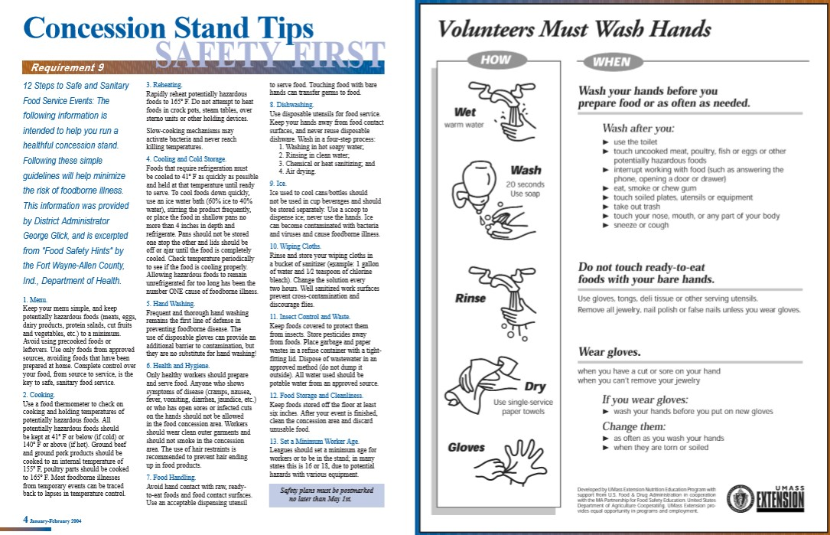
- A fully stocked First Aid Kit will be placed in each Snack Bar

ACCIDENT REPORTING PROCEDURE

What to report -
An incident that causes any player, manager, coach, umpires, or volunteer to receive medical treatment and/or first aid must be reported to the League’s Safety Officer. This includes even passive treatments such as the evaluation and diagnosis of the extent of the injury.

When to report -
All such incidents described above must be reported to the League’s Safety Officer within 24 hours of the incident.

The League’s Safety Officer, Brandon Deering, can be reached at the following:
Phone: 707-333-4577
Email: Brandon.deering707@gmail.com

The League’s Safety Officer’s contact information will be posted at all times on the main message board outside the clubhouse.

How to make a report -
Reporting incidents can come in a variety of forms. Most typically, they are telephone conversations. At a minimum, the following information must be provided:
- The name and phone number of the individual involved.
- The date, time, and location of the incident.
- As detailed a description of the incident as possible.
- The preliminary estimation of the extent of any injuries.
- The name and phone number of the person reporting the incident.

Team Safety Officer’s Responsibility -
The TSO will fill out the Incident/Injury Tracking and submit it to the League’s Safety Officer within 24 hours of the incident. If the team does not have a safety officer then the Team Manager will be responsible for filling out the form and turning it into the League’s Safety Officer. Accidents occurring outside the team (i.e., spectator injuries, and third-party injuries) shall be handled directly by the League’s Safety Officer.

League Safety Officer’s Responsibilities -
Within 24 hours of receiving the Accident Investigation Form, the League’s Safety Officer will contact the injured party or the party’s parents and;
- Verify the information received;
- Obtain any other information deemed necessary;
- Check on the status of the injured party; and
- In the event that the injured party required other medical treatment (i.e., Emergency Room visit, doctor’s visit, et.) will advise the parent or guardian of the Little League insurance coverage and the provision for submitting any claims.

If the extent the injuries are more than minor in nature, the League’s Safety Officer shall:
- Periodically call the injured party to check on the status of any injuries, and
- Check if any other assistance is necessary in areas such as submission of insurance forms, etc., until such time as the incident is considered “closed” (i.e., no further claims are expected and/or the individual is participating in the League again).
- Review and complete where necessary the Incident/Injury Tracking form and route to the appropriate officials.

INSURANCE POLICIES

Little League accident insurance covers only those activities approved or sanctioned by Little League Baseball, Incorporated.

Little League (Majors), Minor League and Tee Ball participants shall not participate as a Little League (Majors), Minor League and Tee Ball team in games with other teams of other programs or in tournaments except those authorized by Little League Baseball, Incorporated.

Little League (Majors), Minor League and Tee Ball participants may participate in other programs during the Little League (Majors), Minor League and Tee Ball regular season and tournament provided such participation does not disrupt the Little League (Majors), Minor League and Tee Ball season or tournament team. Unless expressly authorized by the Board of Directors, games played for any purpose other than to establish a League champion or as part of the International Tournament are prohibited. (See IX - Special Games, pg. 15 in the Rule Book for further clarification)

Little League Insurance Policy is designed to supplement a parent’s existing family policy.

Explanation of Coverage:

The Little League Insurance Program is designed to afford protection to all participants at the most economical cost to the local league. The Little League Player Accident Policy is an excess coverage, accident only plan, to be used as a supplement to other insurance carried under a family policy or insurance provided by parent’s employer. If there is no primary coverage, Little League insurance will provide benefits for eligible charges, up to Usual and Customary allowances for your area, after a $50.00 deductible per claim, up to the maximum stated benefits.

This plan makes it possible to offer exceptional, affordable protection with assurance to parents that adequate coverage is in force for all chartered and insured Little League approved programs and events. If your child sustains a covered injury while taking part in a scheduled Little League Baseball or Softball game or practice, here is how the insurance works:

1. The Little League Baseball and Softball accident notification form must be completed by parents (if the claimant is under 19 years of age) and a league official and forwarded directly to Little League Headquarters within 20 days after the accident. A photocopy of the form should be made and kept by the parent/claimant. Initial medical/dental treatment must be rendered within 30 days of the Little League accident.

2. Itemized bills, including description of service, date of service, procedure and diagnosis codes for medical services/supplies and/or other documentation related to a claim for benefits are to be provided within 90 days after the accident. In no event shall such proof be furnished later than 12 months from the date the initial medical expense was incurred.

3. When other insurance is present, parents or claimant must forward copies of the Explanation of Benefits or Notice/Letter of Denial for each charge directly to Little League Headquarters, even if the charges do not exceed the deductible of the primary insurance program.

4. Policy provides benefits for eligible medical expenses incurred within 52 weeks of the accident, subject to Excess Coverage and Exclusion provisions of the plan.
5. Limited deferred medical/dental benefits may be available for necessary treatment after the 52-week time limit when:

(a) Deferred medical benefits apply when necessary treatment requiring the removal of a pin /plate, applied to transfix a bone in the year of injury, or scar tissue removal, after the 52-week time limit is required. The Company will pay the Reasonable Expense incurred, subject to the Policy’s maximum limit of $100,000 for any one injury to any one Insured. However, in no event will any benefit be paid under this provision for any expenses incurred more than 24 months from the date the injury was sustained.

(b) If the Insured incurs Injury, to sound, natural teeth and necessary treatment requires treatment for that Injury be postponed to some date more than 52 weeks after the injury due to, but not limited to, the physiological changes of a growing child, the Company will pay the lesser of: 1. A maximum of $1,500 or 2. Reasonable Expenses incurred for the deferred dental treatment. Reasonable Expenses incurred for deferred dental treatment are only covered if they are incurred on or before the Insured’s 23rd birthday. Reasonable Expenses incurred for deferred root canal therapy are only covered if they are incurred within 104 weeks after the date the Injury occurs.

No payment will be made for deferred treatment unless the Physician submits written certification, within 52 weeks after the accident, that the treatment must be postponed for the above stated reasons.

Benefits are payable subject to the Excess Coverage and the Exclusions provisions of the Policy.

FILING A CLAIM

When filing a claim, (forms available on-line at www.littleleague.org or from your league safety officer) all medical costs should be fully itemized. If no other insurance is in effect, a letter from the parent’s/guardian’s or claimant’s employer explaining the lack of Group or Employer insurance must accompany a claim form.

On dental claims, it will be necessary to fill out a Major Medical Form, as well as a Dental Form; then submit them to the insurance company of the claimant, or parent(s)/guardian(s), if claimant is a minor. “Accident damage to whole, sound, normal teeth as a direct result of an accident” must be stated on the form and bills. Forward a copy of the insurance company’s response to Little League Headquarters. Include the claimant’s name, League ID, and year of the injury on the form.

This form must be completed by parents (if claimant is under 19 years of age) and a league official and forwarded to Little League Headquarters within 20 days after the accident. A photocopy of this form should be made and kept by the claimant/parent. Initial medical/dental treatment must be rendered within 30 days of the Little League accident.

Itemized bills including description of service, date of service, procedure and diagnosis codes for medical services/supplies and/or other documentation related to claim for benefits are to be provided within 90 days after the accident date. In no event shall such proof be furnished later than 12 months from the date the medical expense was incurred.

Claims must be filed with the League’s Safety Officer. He/she forwards them to

Little League Baseball, Incorporated,
PO Box 3485,
Williamsport, PA, 17701.

Accident Claim Contact Numbers: Phone: 570-327-1674 Fax: 570-326-9280

The League’s Safety Officer will send a copy of the claim to the
D35 Safety Officer Jeff May at 775-771-6963 Email: jeffmay@sbcglobal.net

Contact the League’s Safety Officer for more information.

Safe Sport Act – Child Protection Program

Background Checks
For many years, Little League® has led the way among youth sports organizations in assisting local leagues to keep child sex offenders out of the program.

Little League was the first national youth baseball/softball program to mandate a check of the applicable sex offender registry. Additionally, Little League provides each local Little League with 125 free checks of a national criminal database. More information on that program can be found here: https://www.littleleague.org/player-safety/child-protection-program/

But background checks themselves can only identify those who have already been convicted of crimes. That is why Little League also provides advice – based on information from the FBI and the National Center for Missing and Exploited Children (NCMEC) – on identifying a potential child sex offender.

Reporting Abuse
The “Protecting Young Victims from Sexual Abuse and Safe Sport Act of 2017” mandates that all amateur sports organizations, which participate in an interstate or international amateur athletic competition and whose membership includes any adult who is in regular contact with an amateur athlete who is a minor must report suspected child abuse, including sexual abuse, within 24 hours to law enforcement.

U.S. Federal Law
The “Protecting Young Victims from Sexual Abuse and Safe Sport Act of 2017” mandates that all amateur sports organizations, which participate in an interstate or international amateur athletic competition and whose membership includes any adult who is in regular contact with an amateur athlete who is a minor must report suspected child abuse, including sexual abuse, within 24 hours to law enforcement. According to federal law:
- An individual who is required, but fails, to report suspected child sexual abuse is subject to criminal penalties.
- If an individual suspects a case of abuse within their league, they should report it to the appropriate child services organization and/or local law enforcement as well as, their League President and District Administrator.

State of California Law
Bus. & Prof. Code §18900
A “community youth athletic program” must provide written notice to the parent or guardian of a youth participating in the program regarding the program’s policies relating to criminal background checks for volunteers and hired coaches in the program. If criminal background checks are obtained for hired or volunteer coaches, the written notice shall contain both of the following: (A) a statement regarding whether the criminal background check includes state and federal criminal history information and whether the program obtains subsequent arrest notification for those individuals and (B) contact information regarding where the parent or guardian of a child participating in a “community youth athletic program” can obtain additional information about the program’s background check policy, such as the entity providing the criminal background check or the nature of the type of offenses the program searched. Written notice is satisfied by a posting on the “community youth athletic program’s” website. A “community youth athletic program” is defined as an organization that: (A) has a primary purpose of the promotion or provision of athletic activities for youth under 18 years of age and (B) has adult employees who have supervisory or disciplinary power of children.
The text of Bus. & Prof. Code § 18900 can be viewed online at:
http://leginfo.legislature.ca.gov/faces/codes_displayText.xhtml?lawCode=BPC&division=8.&title=&part=&chapter=2.7.&article=

Who is required to report? All individuals are required to report abuse. Any individual who fails to report suspected child sexual abuse is subject to criminal penalties.
Who is permitted to report? According to “The Protecting Young Victims from Sexual Abuse and Safe Sport Act of 2017” any individual who suspects a case of abuse within their league, they should report it to the appropriate child services organization and/or local law enforcement as well as, their League President and District Administrator
What is the standard for reporting? The circumstances under which a mandatory reporter is required to report vary by state. The DHHS summarizes two typical reporting standards, for both mandatory and permissive reporters: (1) “the reporter, in his or her official capacity, suspects or has reasons to believe that a child has been abused or neglected”; and (2) the reporter has knowledge of, or observes a child being subjected to, conditions that would reasonably result in harm to the child.” Again, work with your attorney to determine when you are required to or should make a report to a state agency.
Is the communication privileged? Some states identify when a communication is privileged, i.e., there is a right to maintain a confidential communication between a professional and their client or patient. However, this privilege is greatly restricted for mandatory reporters. For instance, states commonly provide that the physician-patient privilege is superseded by the requirement to report child abuse.
Will the report be anonymous? Most states permit anonymous reports.
Will the reporter’s identity be disclosed? If a reporter does disclose his/her identity, many states protect the identity of the reporter from disclosure to the alleged perpetrator. In some cases, however, a reporter’s identity may be released (i.e., by court order or by waiver and/or consent).
We also encourage parents and volunteers to read more about abuse and neglect, familiarize themselves with the resources available to report abuse, and learn about the counseling and referral services that are available.

Additional Resources
To read more about mandatory reporting, with a summary of state reporting laws, visit: http://www.childwelfare.gov/systemwide/laws_policies/statutes/manda.cfm

For state (toll-free) child abuse reporting numbers, visit: https://www.childwelfare.gov/contact/

To search the definitions of child maltreatment by state, visit: http://www.childwelfare.gov/systemwide/laws_policies/state/

For crisis assistance, counseling, and referral services:
Childhelp is a national organization that provides crisis assistance and other counseling and referral services. The Childhelp National Child Abuse Hotline is staffed 24 hours a day, 7 days a week, with professional crisis counselors. All calls are anonymous. Contact them at 1.800.4.A.CHILD (1.800.422.4453), or visit http://www.childhelp.org/.

For Abuse Awareness Training for coaches and volunteers, please visit:
US Center for Safe Sport https://uscenterforsafesport.org
USA Baseball https://www.usabaseball.com/about/safesport

Finger-Print Background Check Program
As a Little League® volunteer in California, we want to share an important update regarding a new state law to protect children from sexual abuse in youth organizations, including Little League. California passed a new legislative bill, Assembly Bill No.506, that requires a fingerprint-based background check and child abuse and neglect reporting training for individuals who volunteer more than 16 hours a month or 32 hours a year; which, for Little League, includes coaches, managers, board members, umpires, etc.
The bill requires organizations to have policies to ensure that regular volunteers are reporting suspected incidents of child abuse. It also requires the presence of at least two mandated reporters when interacting with children. This law will go into effect statewide on January 1, 2022. Fortunately, Little League International has the Child Protection Program that must be followed by all Little League programs and volunteers are already considered mandated reporters due to the SafeSport law enacted in 2018 .
What Leagues Need to Know:
The new background check requirement by the state is pursuant to Section 1105.3, which is a California Department of Justice State fingerprint check through Live Scan locations. This background check does not replace the required Little League background check , which is a search of the National Criminal database, National Sex Offender Registry, U.S. Center for SafeSport Centralized Disciplinary Database, and the Little League International Ineligible List. Local Little League volunteers must conduct training for child abuse and neglect reporting training. Leagues can utilize the USA Baseball training, which is free to all volunteers: Abuse Awareness for Adults.

What Leagues Need to Do:
A Little League-appointed board member must oversee the background check process for the league, including the new requirements under California law. Below is a breakdown of the California background check process which includes the application process to acquire an Originating Agency Identifier (ORI) code:
- Complete the California Department of Justice Application for Authorization Pursuant to Penal Code Section 11105.3 (Youth Organizations-Human Resource Agencies).
- For this application, you will need your local Little League's proof of non-profit status. Local Little Leagues that cannot show proof of their non-profit status may incur additional fees.
- Mail the completed application to the California Department of Justice Applicant Information and Certification Program (address is listed on the application).
- Your league will receive an ORI code which will identify your organization when the volunteer completes the fingerprint process.
- The league must provide the ORI code to volunteers to complete the fingerprint process through Live Scan.
Leagues cannot request fingerprints until they receive the ORI code and authorization from the California Department of Justice.
What Volunteers Need to Know:
Volunteers will be required to go through this process for each league and/or other non-profit they volunteer for; therefore, it is strictly prohibited to share the fingerprint background check results with other local Little Leagues or other non-profits.
- Request an ORI number from the local Little League.
- A league volunteer must use the correct ORI code for their local Little League.
- Select a Live Scan location to conduct the fingerprints.
- Complete the included form 8016- Request for Live Scan Services either online or bring the completed form with you to the Live Scan location.
The fingerprint background check can cost from $15 to $70 depending on the Live Scan location. The local Little League volunteer would be responsible for the fingerprint background check cost.

IMMUNITY FROM LIABILITY

According to Boys & Girls Clubs of America, “Concern is often expressed over the potential for criminal or civil liability if a report of abuse is subsequently found to be unsubstantiated.” However, we want adults and Little Leaguers to understand that they shouldn’t be afraid to come forward in these cases, even if it isn’t required and even if there is a possibility of being wrong. All states provide immunity from liability to those who report suspected child abuse in “good faith.” At the same time, there are also rules in place to protect adults who prove to have been inappropriately accused.

Make Our Position Clear
Make adults and kids aware that Little League Baseball and our local League will not tolerate child abuse, in any form.

The Buddy System
It is an old maxim, but it is true: There is safety in numbers. Encourage kids to move about in a group of two or more children of similar age, whether an adult is present or not. This includes travel, leaving the field, or using the restroom areas. It is far more difficult to victimize a child if they are not alone.

Access
Controlling access to areas where children are present -- such as the dugout or restrooms -- protects them from harm by outsiders. It’s not easy to control the access of large outdoor facilities, but visitors could be directed to a central point within the facility. Individuals should not be allowed to wander through the area without the knowledge of the Managers, Coaches, Board Directors or any other Volunteer.

Lighting
Child sexual abuse is more likely to happen in the dark. The lighting of fields, parking lots and any and all indoor facilities where Little League functions are held should be bright enough so that participants can identify individuals as they approach, and observers can recognize abnormal situations.

Toilet Facilities
Generally speaking, Little Leaguers are capable of using toilet facilities on their own, so there should be no need for an adult to accompany a child into rest room areas. There can sometimes be special circumstances under which a child requires assistance to toilet facilities, for instance when the T-Ball and Challenge divisions, but there should still be adequate privacy for that child. Again, we can utilize the “buddy system” here.

TRANSPORTATION

Before any manager or designated coach can transport any child, other than his/her own, anywhere, he or she must:

- Have a valid California Driver’s License and current liability insurance.

- Not carry more children in their vehicle than they have seat belts for.
- When transporting a child who ages are 5 & 6 that they placed within the CA approved child seat.
- Make sure that the vehicle is in good running order and that it would pass a CHP vehicle safety inspection if spontaneously given.
- Not drive in a careless or reckless manner.

- Not drive under the influence of alcohol, drugs, or medication.

- Obey all traffic laws and speed limits at all times.

- Never transport a child without returning him/her to the point of origin.

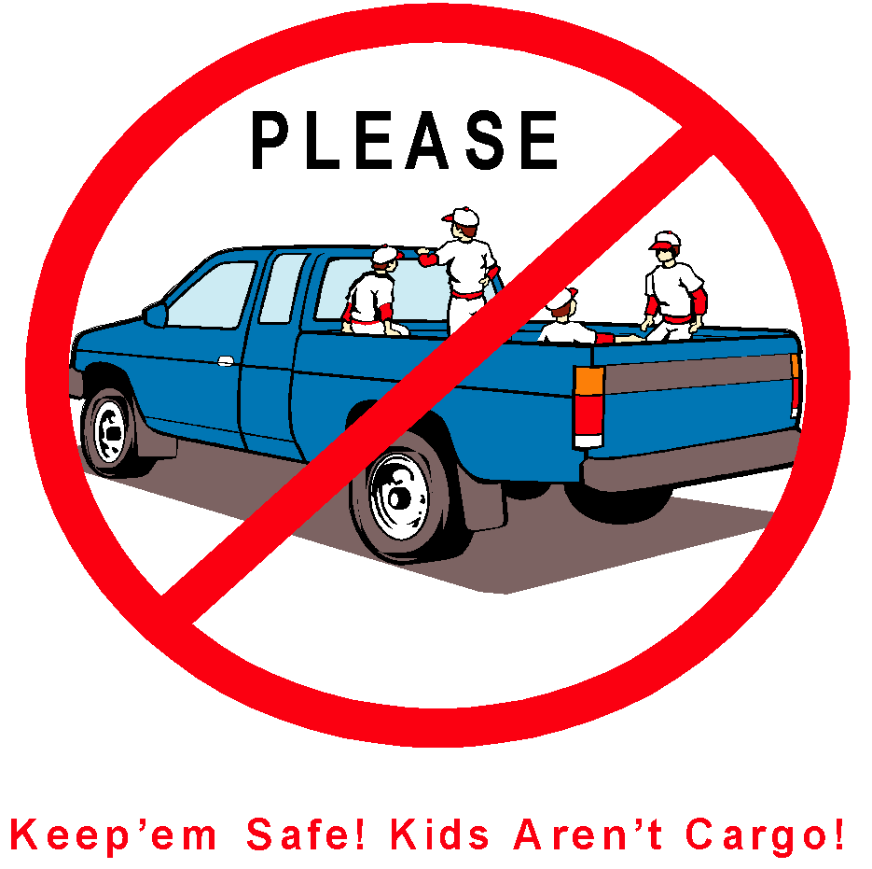

Forms

Table of Contents

- Safety Manual and First Aid Kits
- Incident / Injury Tracking Report
- Medical Release
- AIG Accident Notification Form
- Little League Volunteer Application Form
- Little League “Basic” Volunteer Application Form
- Little League Baseball Game Pitch Log
- Little League Baseball Pitcher Eligibility Tracking Log

SAFETY MANUAL AND FIRST AID KITS

Each Manager, Coach, Player Agent, and League Official will be issued a Safety Manual and a First Aid Kit at the beginning of the season. The manager will acknowledge the receipt of both by signing in the space provided below when taking possession of these articles.

Five chemical ice packs of physical therapy quality will be issued to each team at the beginning of the season. Others are available at all times in the concession stands.

Each team dugout will have a First Aid Kit and a Safety Manual in plain sight at all time in.

The Safety Manual will include phone numbers for all Board Directors, the League Code of Conduct, Do’s and Don’ts of treating injured players.
.
The First Aid Kit will include the necessary items to treat an injured player until professional help arrives if need be.

(Detach Section below and return to the League Safety Officer)

I have received my 2022 League Safety Manual and my team First Aid Kit and will have them both present at all practices, batting cage practices, games (season games and post-season games) and any other event where team members could become injured or hurt. I realize it my responsibility to ensure that my First Kit is always properly stocked in coordination with my Safety Officer.

Print Manager’s Name Team Name / Division

Manager’s Signature Date

